

**HADHRAMOUT UNIVERSITY**

**COLLEGE OF ENGINEERING & PETROLEUM**

**COMPUTER ENGINEERING DEPARTMENT**

**University lecture timetable scheduling**

**A FINAL PROJECT SUBMITTED IN PARTIAL FULFILMENT OF THE REQUIREMENTS FOR THE DEGREE OF BACHELOR OF ENGINEERING IN COMPUTER ENGINEERING**

**By**

**Abdulrahman Ahmed Bahyan**

**Halah Marie Bin Helabi**

**Hasan Mohammed Al-Hamed**

**Mareai Faozi Bin Taleb**

**Supervised By**

**Dr. Makarem Bamatraf**

**ALMUKALLA**

**JULY 202****3**

# Table of Contents

Table of Contents 2

Table of Figures 3

1 Project Introduction 4

1.1 Introduction 4

1.2 Problem statement 4

1.3 Objectives 4

1.4 Project scope 4

2 LITERATURE REVIEW 5

2.1 Introduction 5

1.1 Related Work 5

2.1.1 Making a School Schedule from GOV.SA 5

2.1.2 Scheduly 7

2.2 Background 8

2.2.1 Genetic Algorithm 8

2.2.2 Front End 9

2.2.3 Back End 11

2.2.4 Development Environment 12

3 METHODOLOGY 13

3.1 INTRODUCTION 13

3.2 Analysis 13

3.2.1 Creating timetable manually 13

3.2.2 Creating the timetable using the genetic algorithm 16

3.2.3 Users of the system and their use case 18

3.2.4 The dataflow the system 22

3.2.5 Database of the system 23

References 25

# Table of Figures

Figure ‎2‑1 Making Schedule School page on GOV.SA website 6

Figure ‎2‑2 School Schedule page on manger of school account 6

Figure ‎2‑3 generating schedule page on manger of school account 6

Figure ‎2‑4 Dashboard for Scheduly program 7

Figure ‎2‑5 Output page of Scheduly program 7

Figure ‎3‑1 Manual way to create a timetable 15

Figure ‎3‑2 flowchart to generate the timetable using the genetic algorithm 17

Figure ‎3‑3 Use case of the Admin 18

Figure ‎3‑4 Use case of head of department 20

Figure ‎3‑5 Use case of college secretary 21

Figure ‎3‑6 Context diagram 22

Figure ‎3‑7 Dataflow diagram 23

Figure ‎3‑8 dataflow diagram of multiple processes (assign lecturers) 23

Figure ‎3‑9 Entity relationship diagram 24

Table ‎3‑1 Use case of Admin 18

Table ‎3‑2 Use case of Head of Department 19

Table ‎3‑3 Use case of college secretary 20

# CHAPTER 1

# PROJECT INTRODUCTION

## INTRODUCTION

Today we are progressing in science and technology and everything is moving towards automation a large portion of this technology is developed to solve tasks that take a lot of time to be done manually. These tasks are real-life problems, which are classified into two categories. The first category is the deterministic problems which are the problems with no randomness, meaning that all data to find the best solution are present so you can determine the solution with no difficulties. The second category is the non-deterministic problems where there is the factor of randomness so finding a solution will be a more complex task also where there are too many possibilities to find a solution. This is because of the large pool of spaces for solutions, and handling such large spaces concerning certain circumstances or constraints will be extremely difficult. Here comes the automation part where you can use the machine to do large tasks and repeat them thousands of times so the near-optimal solution can be obtained.

## PROBLEM STATEMENT

In each semester, universities create their lecture schedules. This process is done manually and it is not easy due to the many aspects that must be considered and taken into accounts, such as lectures, appropriate halls, time of lecture. There is a possibility to improve these schedules and come up with more satisfactory results, but it takes effort and a long time that exceeds the ability of the average person. Here the problem lies in creating schedules that are free of conflicts and adequately meet the requirements of faculty members and students.

## OBJECTIVES

The objectives of this project are to create a program that can:

* Generate university lectures schedules that have no conflicts and satisfy users' requirements.
* Optimize the obtained schedules.
* Reducing the time and effort taken to create the schedules by transforming the manual task to an automated one.

## PROJECT SCOPE

This project will be implemented at Hadhramout university, but also other universities can benefit from the project by adapting it for their use. Firstly, the project will be tested in the college of engineering and petroleum which allow the departments to create their semester schedule as they need.

# CHAPTER 2

# LITERATURE REVIEW

## INTRODUCTION

This chapter gives an overview of the applications That have the same concept of the trying to generate timetables automatically, which are related to this project. Also, it will give a brief description of the technologies that will be used to build this project in the background section.

## RELATED WORK

Creating schedules is not considered a recent problem. It has long been a challenge for everyone who needs to create a schedule to organize some work. Therefore, it is natural to find some devised ways to solve this problem, and universities are not excluded from this issue. Many universities have developed programs that prepare schedules. The university and schedules for students.

### Making a School Schedule from GOV.SA

An e-service provided by the Ministry of Education in KSA, enabling school administrators to create study schedules through the Noor system.[1]

Steps to make a school schedule are:

* Login to the Noor system.
* Select the school schedule.
* Select (Prepare and implement the table).
* Complete the table setting steps.
* The schedule is complete.

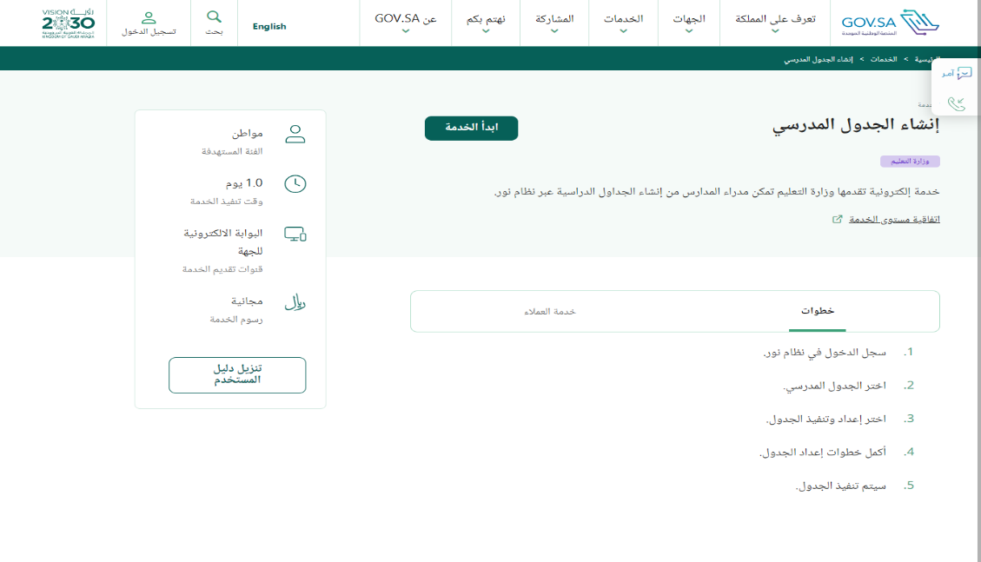

Figure ‑ Making Schedule School page on GOV.SA website

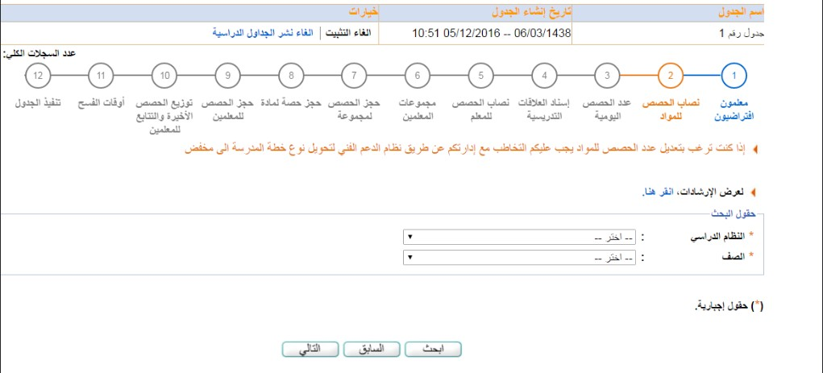

Figure ‑ School Schedule page on manger of school account

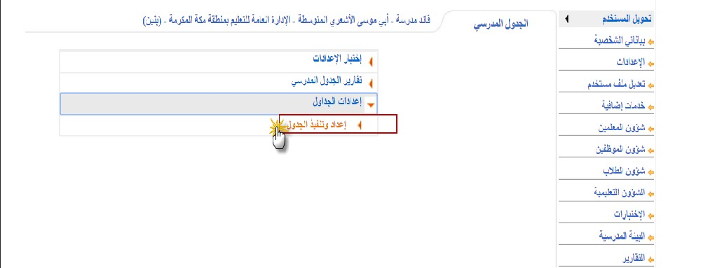

Figure ‑ generating schedule page on manger of school account

### Scheduly

The goal of the software application is to provide a possible timetable solution with the minimum number of clashes between time slots. It relieves the user of much of the hard work required for generating a timetable manually, leaving him with more time to apply the skills and judgment where they are needed to produce a timetable of the highest quality.[2]

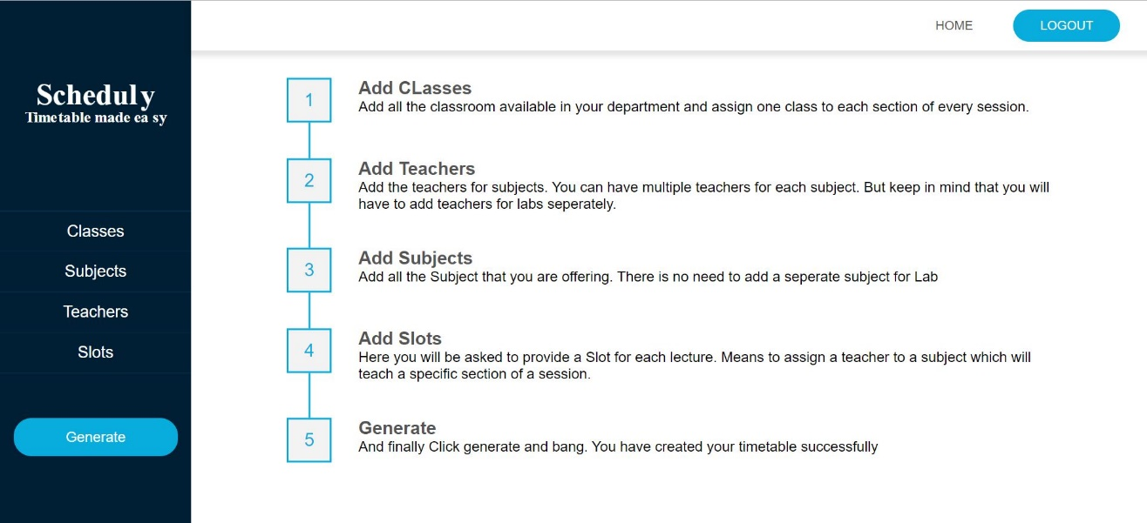

Figure ‑ Dashboard for Scheduly program

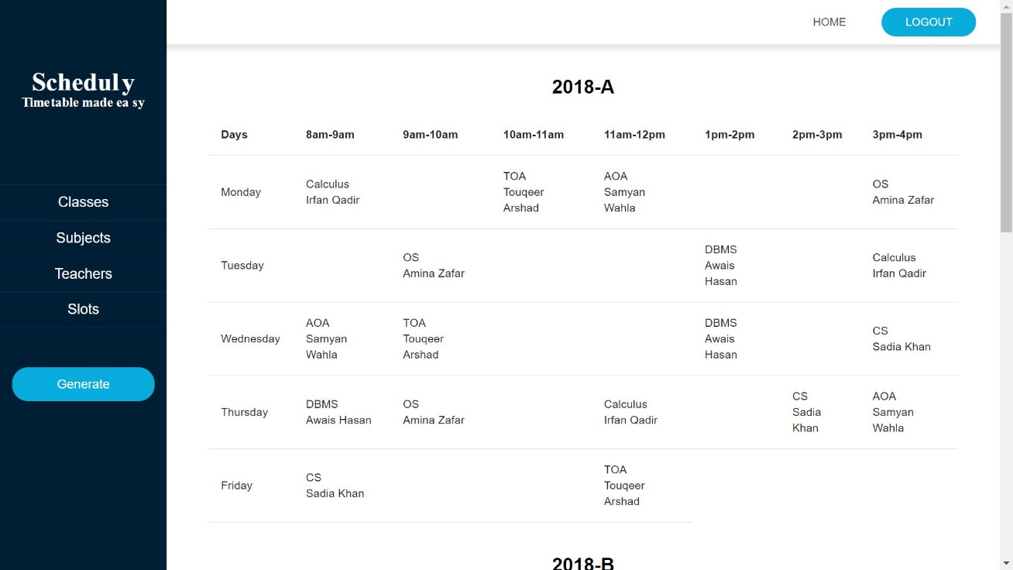

Figure ‑ Output page of Scheduly program

## BACKGROUND

In this section we will give a brief definition of the technologies and tools we are using to build this project, mainly we are building web applications, and these applications will depend on an algorithm called a Tabu search. and the technologies we will use can be categorized into two main sections, Front End and Back End.

### Tabu Search

Tabu search is a metaheuristic optimization technique that is used to solve combinatorial optimization problems. It is a local search algorithm that is designed to avoid getting stuck in local optima by keeping a record of previously visited solutions called a "tabu list". The basic idea of tabu search is to iteratively improve a candidate solution by making small modifications to it while avoiding moves that are prohibited by the tabu list. The tabu list prevents the algorithm from revisiting recently visited solutions, which encourages exploration of the search space and helps to avoid getting stuck in local optima. Tabu search has been successfully applied to a wide range of optimization problems, including scheduling, routing, and packing problems. One of the strengths of tabu search is its ability to handle large and complex problems with many variables and constraints. There are many variations of tabu search, including adaptive tabu search, reactive tabu search, and parallel tabu search. These variations introduce additional techniques to improve the algorithm's performance and make it more efficient.[3], [4]

#### How Tabu Search Works

The basic idea of tabu search is to iteratively improve a candidate solution by making small modifications to it while avoiding moves that are prohibited by the tabu list. here are the steps of how tabu search works:

1. Initialize the algorithm with an initial solution to the problem.
2. Define a tabu list to keep track of the moves that have been made in previous iterations.
3. Define a neighborhood structure that defines the set of possible moves that can be made to the current solution.
4. Generate a set of candidate solutions by applying the neighborhood structure to the current solution.
5. Evaluate the quality of each candidate solution using an objective function.
6. Select the best candidate solution that is not prohibited by the tabu list.
7. Update the tabu list to include information about the move that was just made.
8. Repeat steps 4-7 until a stopping criterion is met (e.g., a maximum number of iterations is reached, or a satisfactory solution is found).
9. Return the best solution found during the search.[3], [4]

### Front End

The Front End of an application is the interfaces, and all that can the end user see or interact with on the screen of that application.

#### HTML

HTML stands for Hyper Text Markup Language and it is the standard markup language for creating Web pages. HTML describes the structure of a Web page; elements of HTML tell the browser how to display the content.

A start tag, some content, and an end tag define an HTML element:

<tagname> Content goes here... </tagname>

To read HTML documents and display them we need to use a browser such as Chrome or Firefox.[5]



#### CSS

CSS stands for Cascading Style Sheets and describes how HTML elements are to be displayed on the screen, paper, or in other media. CSS saves a lot of work it can control the layout of multiple web pages all at once.

HTML was never intended to contain tags for formatting a web page, it was created to describe the content of a web page, when tags like <font>, and color attributes were added to the HTML 3.2 specification, it started a nightmare for web developers. Development of large websites, where fonts and color information were added to every single page, became a long process.[6]

#### D:\College\Mini Project\Our project\images\JavaScript.pngJavaScript

JavaScript is a programming language that is one of the core technologies of the World Wide Web, alongside HTML and CSS. Over 97% of websites use JavaScript on the client side for web page behavior, often incorporating third-party libraries. All major web browsers have a dedicated JavaScript engine to execute the code on users' devices. JavaScript is a high-level, often just-in-time-compiled language that conforms to the ECMAScript standard. It has dynamic typing, prototype-based object orientation, and first-class functions. It is a multi-paradigm, supporting event-driven, functional, and imperative programming styles and it has application programming interfaces (APIs) for working with text, dates, regular expressions, standard data structures, and the Document Object Model (DOM).[7]

#### ReactReact.js

React, sometimes referred to as a frontend JavaScript framework, is a JavaScript library created by Facebook. React is a tool for building UI components. Instead of manipulating the browser's DOM directly, react creates a virtual DOM in memory, where it does all the necessary manipulating and is found out what changes have been made, and changes only what needs to be changed, before making the changes in the browser DOM.[8]

### Back End

On the opposite side of the Front End, The Back End is all the underneath structures and data management in the background of an application that is hidden from the end user, it is responsible for storing and organizing data, and the backend communicates with the frontend, sending and receiving information to be displayed.

#### NodeNode.js

Node.js is an open-source and cross-platform JavaScript runtime environment. Node.js runs the V8 JavaScript engine, the core of Google Chrome, outside of the browser. This allows Node.js to be very performant. A Node.js app runs in a single process, without creating a new thread for every request. Node.js provides a set of asynchronous I/O primitives in its standard library that prevent JavaScript code from blocking and generally, libraries in Node.js are written using non-blocking paradigms, making blocking behavior the exception rather than the norm. When Node.js performs an I/O operation, like reading from the network, or accessing a database or the file system, instead of blocking the thread and wasting CPU cycles waiting, Node.js will resume the operations when the response comes back. This allows Node.js to handle thousands of concurrent connections with a single server without introducing the burden of managing thread concurrency, which could be a significant source of bugs. Node.js has a unique advantage because millions of frontend developers that write JavaScript for the browser are now able to write the server-side code in addition to the client-side code without the need to learn a completely different language.[9]

#### MySQL

MySQL is one of the most recognizable technologies in the modern big data ecosystem. Often called the most popular database and currently enjoying widespread, effective use regardless of industry, anyone involved with enterprise data or general IT should at least aim for a basic familiarity with MySQL. MySQL is a relational database management system (RDBMS) developed by Oracle that is based on structured query language (SQL).

A database is a structured collection of data. It may be anything from a simple shopping list to a picture gallery or a place to hold vast amounts of information in a corporate network. In particular, a relational database is a digital store collecting data and organizing it according to the relational model. In this model, tables consist of rows and columns, and relationships between data elements all follow a strict logical structure. An RDBMS is simply a set of software tools used to implement, manage, and query such a database.[10]

### Development Environment

To be able to use these technologies all of them need an environment that hosts them and as we going to use the best technology, we will use the best environments.

#### Visual Studio Code

Visual Studio Code is a source-code editor made by Microsoft for Windows, Linux, and mac OS. Features include support for debugging, syntax highlighting, intelligent code completion, snippets, code refactoring, and embedded Get. Users can change the theme, keyboard shortcuts, and preferences, and install extensions that add additional functionality.

**Features**

* Visual Studio Code is a source code editor that can be used with a variety of programming languages, including Java, Go, JavaScript, Python, and C++.
* Is based on the Electron framework, which is used to develop Node.js web applications that run on the Blink layout engine.
* Instead of a project system, it allows users to open one or more directories, which can then be saved in the workspace for future reuse.
* Visual Studio Code can be extended via extensions available through a central repository. This includes additions to the editor and language support, extending and customizing to your liking.[11]

# CHAPTER 3

# METHODOLOGY

## INTRODUCTION

This chapter explains the methodology used in this project with the analysis of all its aspects, how the end user will interact with all the data available to him through the application, and how data flow between each of the users and the system to get the best results in terms of timetable. Then, it will address the design of the database and how it fills the database table through which the timetable is created. Finally, the interfaces of the project and how they will be designed so that both ease of use and effectiveness for the user are taken into account, with an explanation of some of them.

## ANALYSIS

### Creating Timetable Manually

At this stage, it is analyzed how timetables are created by the university and what steps are taken to make this process as smooth as possible. After checking with the heads of departments and the secretary in the College of Engineering and Petroleum, it was found that the university's timetable is established with the following steps:

1. Determining the study subjects Each department head determines the subjects that will be studied at each level of his department, except for the first level, where most of the subjects are the responsibility of the college secretary. These subjects are determined according to the study plan followed for each department.
2. Assign lecturers The head of the department assigns the lecturers to each of the specified subjects according to their capabilities and requests. As previously mentioned, the subjects of the first level are determined by the college secretary, so he is also the one who determines the lecturers for them. In the absence of lecturers from the department for the subject, the head of the department or the secretary of the college may have to send a request to the head of another department to give him a lecturer capable of teaching that subject.
3. Hall distribution At this stage, the halls are distributed to each group of all levels according to the number of students and the capacity of the hall. Here, the college uses a method to facilitate this process by defining a number of its halls for each department that takes priority over other departments. While keeping the large halls and allocating them to first-level students from all departments, these halls will be at the disposal of the college secretary. In the event of a conflict between the halls, or if the number of students exceeds the capacity of the hall, the head of the department or the secretary resorts to sending a request to one of the other departments to give him one of their halls, if it is. Available according to his needs, or to exchange if there is a group from the other section to fit in the hall.
4. Timing for lectures At this stage, the timetable begins to form, where the department head or secretary arranges the timetable with the day for each lecture according to the following information:

* Subject
* Duration of lecture
* Lecturer
* Hall
* Group.

1. Checking for conflicts The final stage of creating the timetable is to check for discrepancies between timetables created by all departments. This is done by a specific person, and in the event of a conflict, he reviews the sections in which the dispute occurred to try to solve the problem either by changing the timing of some lectures or changing the rooms. This process is repeated until a timetable for all departments is produced free of conflicts.
2. Distribution of the created timetables After the timetable is created then it is distributed to the college students and lecturers.

These are the steps followed in each semester by the college in creating timetables for each semester and in the following figure (figure 3-1) a simplification of the process to make it easier to visualize.

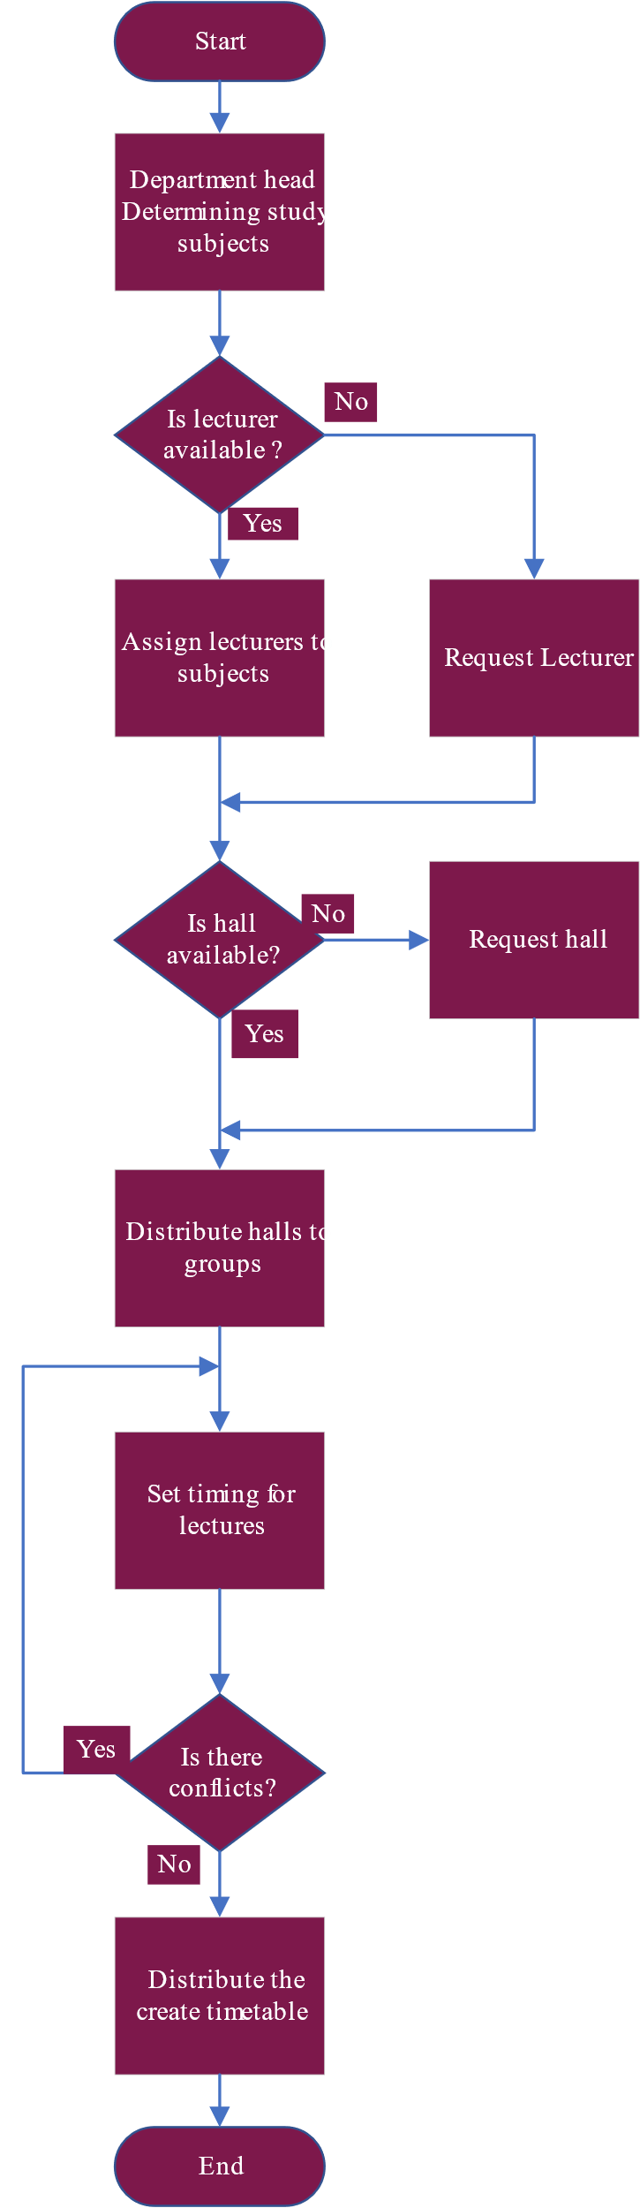

The process of finding conflicts and trying to solve them is done by a specific person.

When assigning a lecturer, take into consideration his requests and capabilities

Figure ‑ Manual way to create a timetable

### Creating Timetable Using Tabu Search

After understanding how to create the timetable, here comes the role of the Tabu search to convert this process into an automatic process to reduce the time required to produce a timetable and be free of conflicts. The steps used to get the timetable are almost the same. The department head or college secretary has to select the subjects and lecturers for each subject, after which the algorithm starts taking this data and creates the timetable according to the constraints imposed on it. Constraints are divided into two types, hard constraints, which are used to prevent any cases of conflict, and there are also soft constraints, which are used to generate schedules according to some department preferences. Here are some constraints two follow:

Hard constraints:

* The lecturer does not teach two subjects at the same time
* The hall does not contain two groups at the same time
* The group does not take two subjects at the same time

Soft constraints:

* Set the time and day that suits the lecturer
* Don't take too much free time between lectures.
* Schedule practical subjects for the same day

So, to generate a timetable using the Tabu search as mentioned earlier, the first few steps are the same as those in the manual method with the difference that the Tabu search starts to take the lead after it has the data needed to create the best timetable, and it follows these steps:

1. Determine the study subjects. (manually)
2. Assign the lecturers. (manually)
3. The algorithm distributes the hall and manages the timing for the lectures.
4. The generated timetable is distributed to the college students and lecturers.

These are the steps used to create the timetable using Tabu search and to get a good understanding of the concept of it and visualize see (figure 3-2).

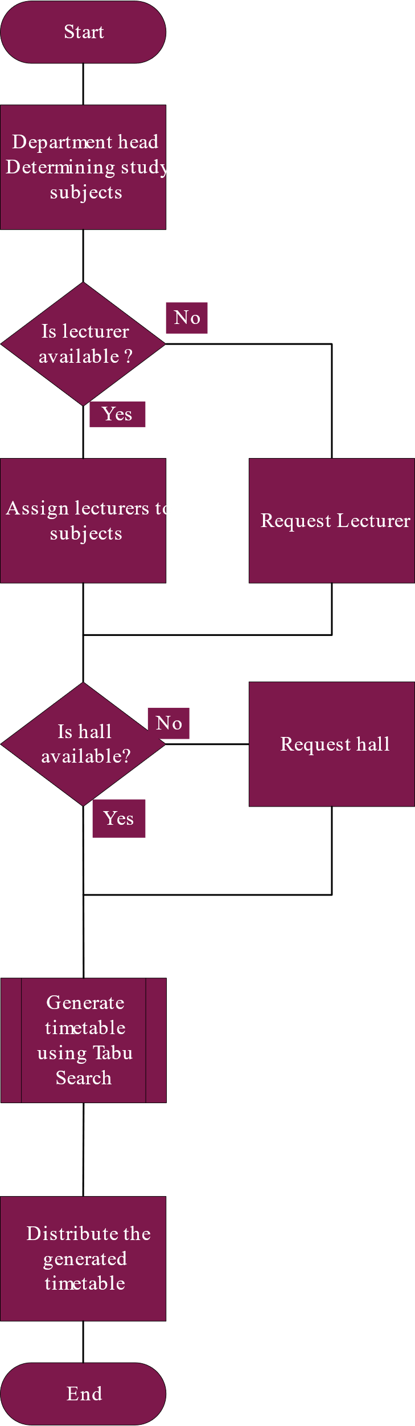

Figure ‑ flowchart to generate the timetable using the genetic algorithm

### Users of the system and their use case

From the analysis, you find that the Tabu search needs users who give it the necessary data to generate the timetables, and these users are the ones who control the results that the algorithm will give, and they are:

* Admin of the system.
* Head for the department.
* College secretary.

#### Admin of the system

The system administrator will be responsible for operating the timetable generation system within the college campus and will also be assigned to perform some other tasks. His task is noted below with some explanation and to visualize see (figure 3-3).

Table ‑ Use case of Admin

|  |  |
| --- | --- |
| Use case 1 | Add users |
| Flow | When the system is first implemented in the college the administrator's job is to give access to a few of the users that will use the system to generate the timetables. |
| Use case 2 | Define the structure of the college |
| Flow | When the system is first implemented in the college the administrator's job is to define the structure of the college that the system is implemented in which include the hall and their types and capacity also which building it’s located in |

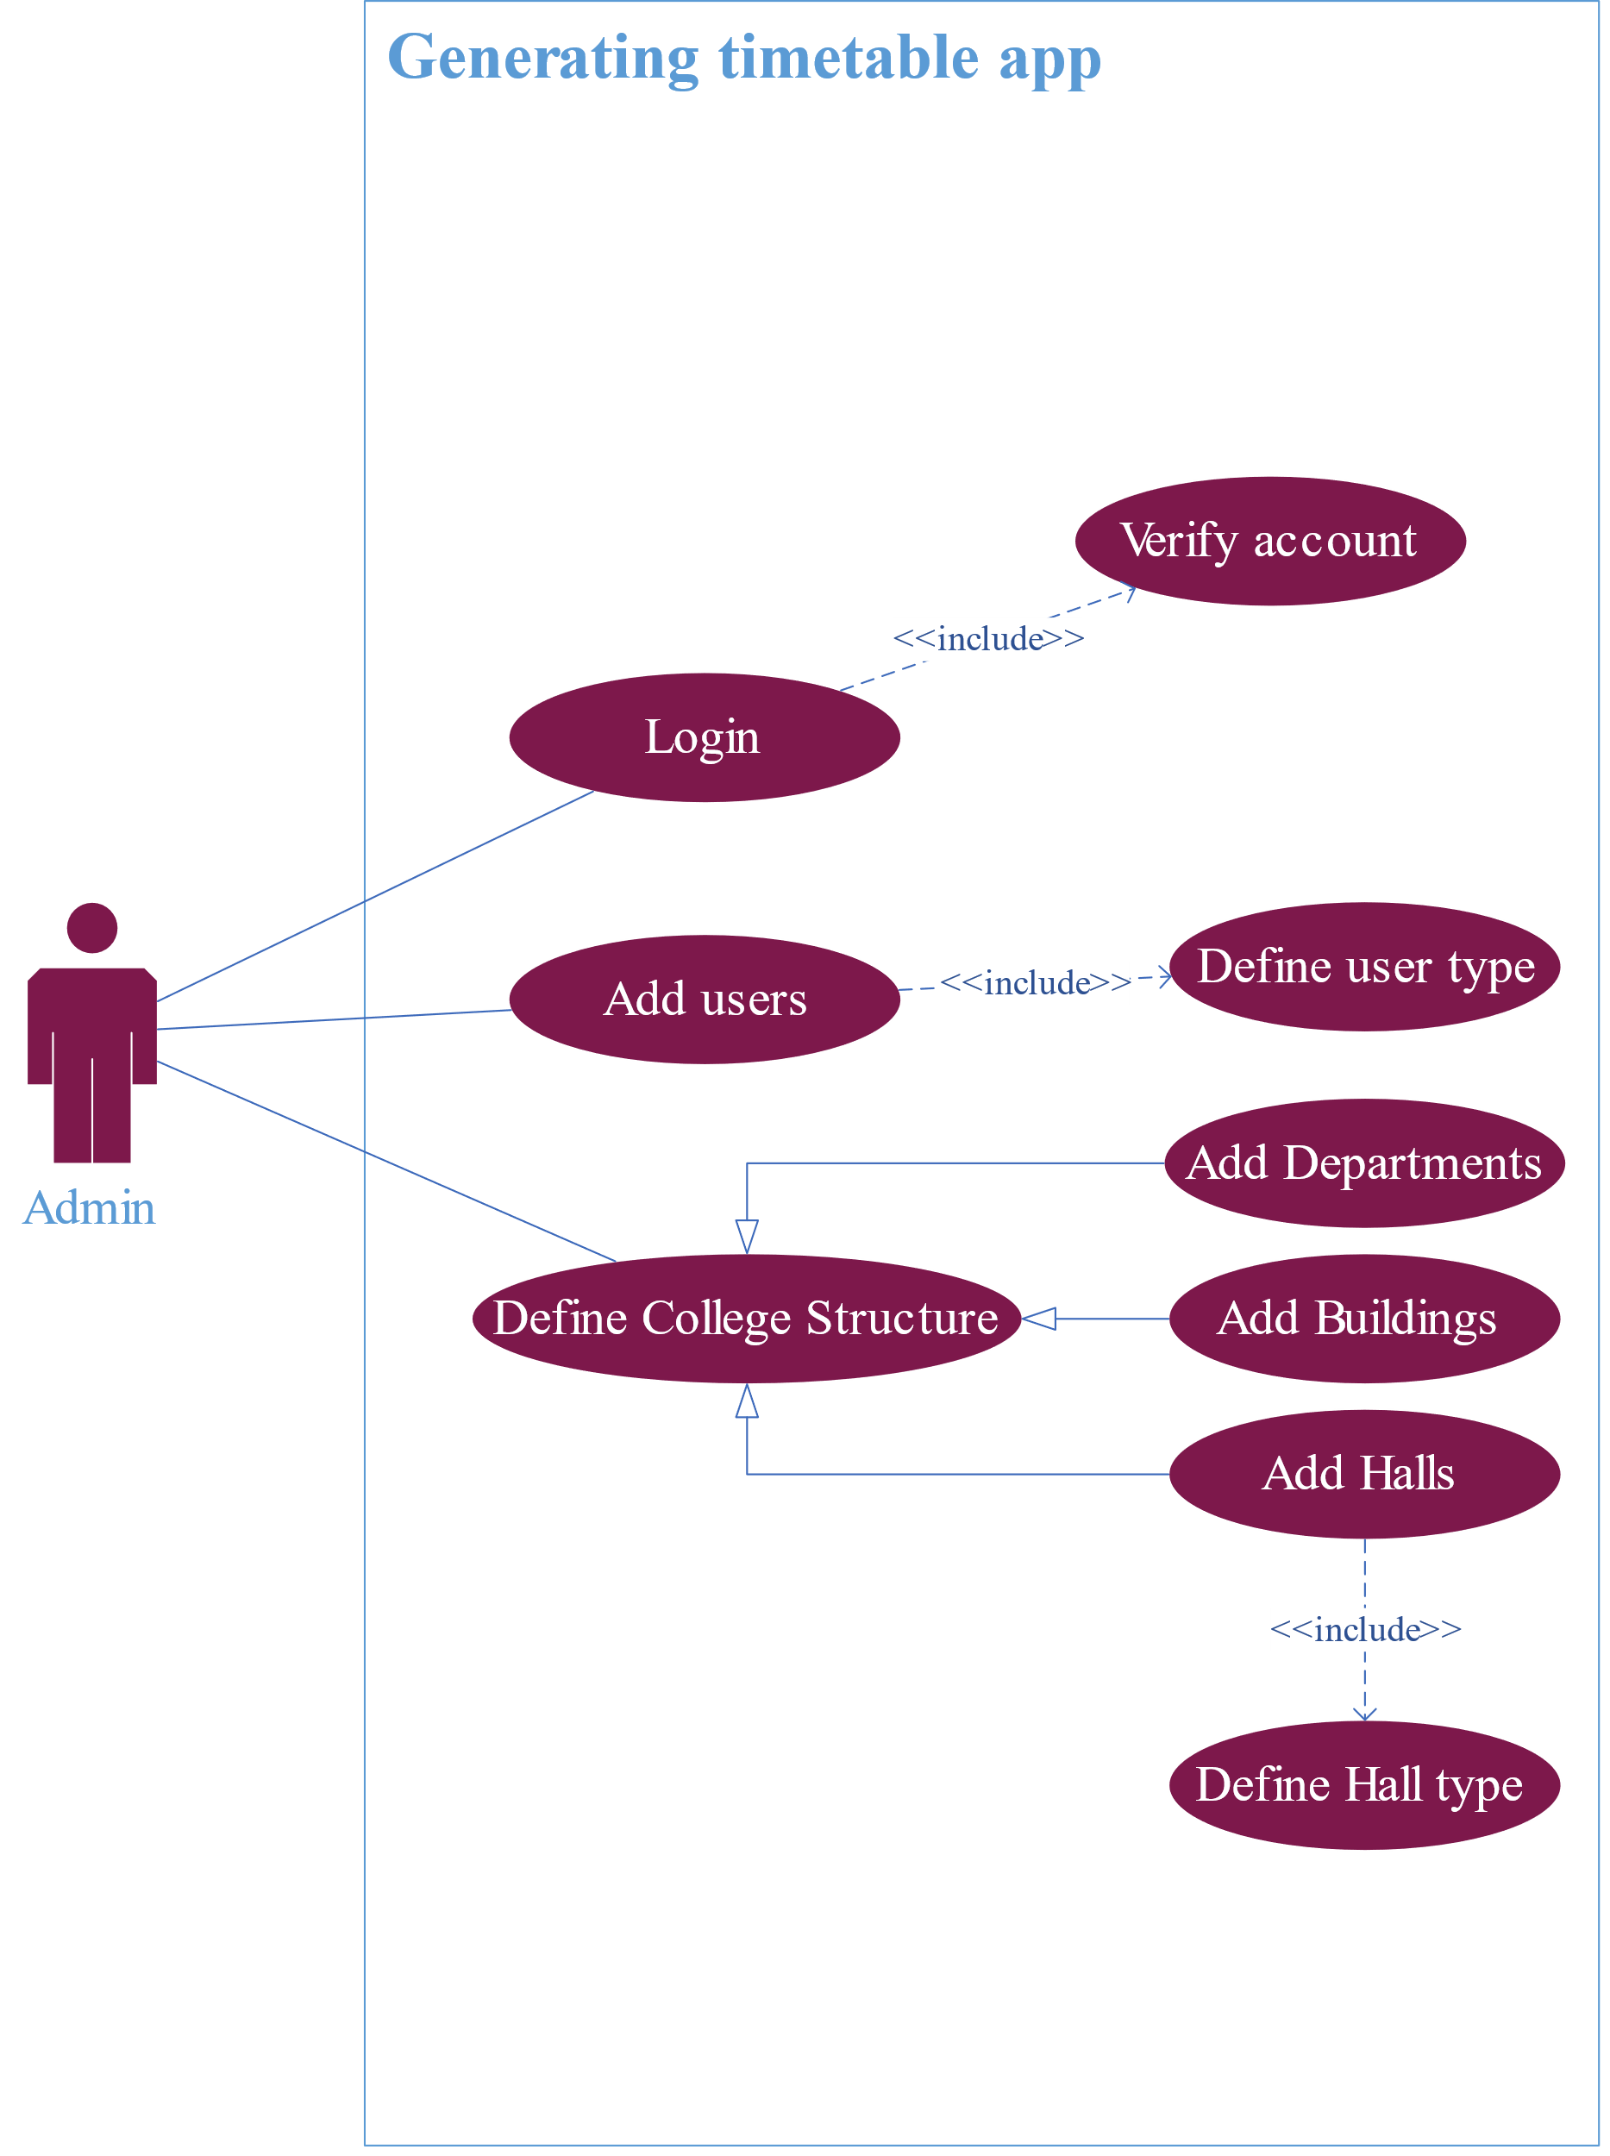

Figure ‑ Use case of the Admin

#### Head of the department

The head of the department is one of the main users of the system, as he is responsible for entering most of the important data that make the system effective. Below is an explanation of what he does in the system, and to visualize it, see (figure 3-4.(

Table ‑ Use case of Head of Department

|  |  |
| --- | --- |
| Use case 1 | Modify Courses |
| Flow | The department head is responsible for adding courses prescribed by the college to the system. He adds study subjects and their characteristics and may modify them or even remove them. |
| Use case 2 | Modify Groups |
| Flow | The department head is responsible for defining the groups of his department. He adds new groups and their characteristics and may modify them or even remove them. |
| Use case 3 | Assign lecturers |
| Flow | The department head is responsible for adding lecturers to the system with their preferences and assigning them to subjects so they teach them. Also, he can assign lecturers to requests from other users of the system. |
| Use case 4 | Request lecturers |
| Flow | If the department head needed a lecturer for a subject but didn’t have one available, he can request a lecturer from another user of the system. |
| Use case 5 | View Halls |
| Flow | The department head can view the halls if he needed to. |

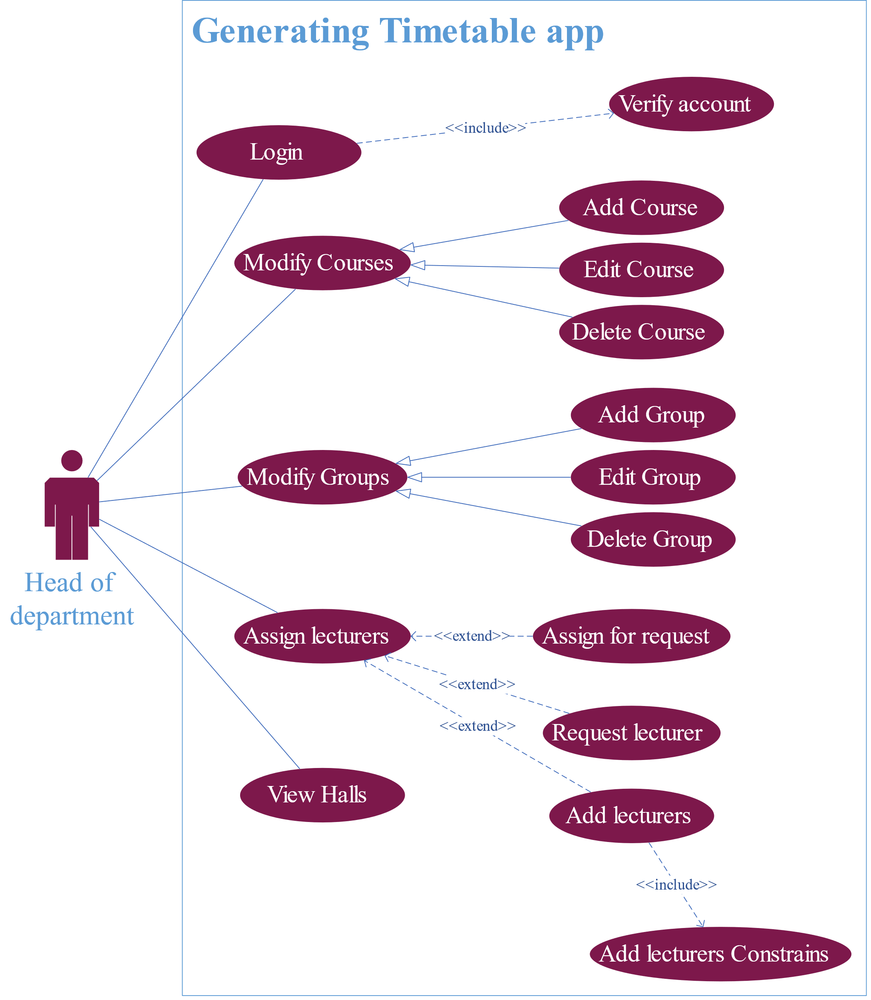

Figure ‑ Use case of head of department

#### College secretary

|  |  |
| --- | --- |
| Use case 1 | Assign lecturers |
| Flow | The college secretary is responsible for adding lecturers of the first-level students to the system with their preferences and assigning them to subjects so they teach them. Also, he can assign lecturers to requests from other users of the system. |
| Use case 2 | View Halls |
| Flow | The college secretary can view the halls if he needed to. |

The college secretary is also one of the main users of the system, as he is responsible for first-level students from all departments because most of the subjects they have in common are prescribed by the college, so he is responsible for their lecturers. Also, he is the one who makes sure in the system that all of the rest of the users have added all their data so that the algorithm can work. Below is an explanation of what he does in the system, and to visualize it, see (figure 3-5.(

Table ‑ Use case of college secretary

|  |  |
| --- | --- |
| Use case 3 | Start generation of timetable |
| Flow | The secretary is responsible for making sure that all the users have submitted their data that allow the Tabu search to generate the timetable when everything is ready, he signals to the algorithm to start. |

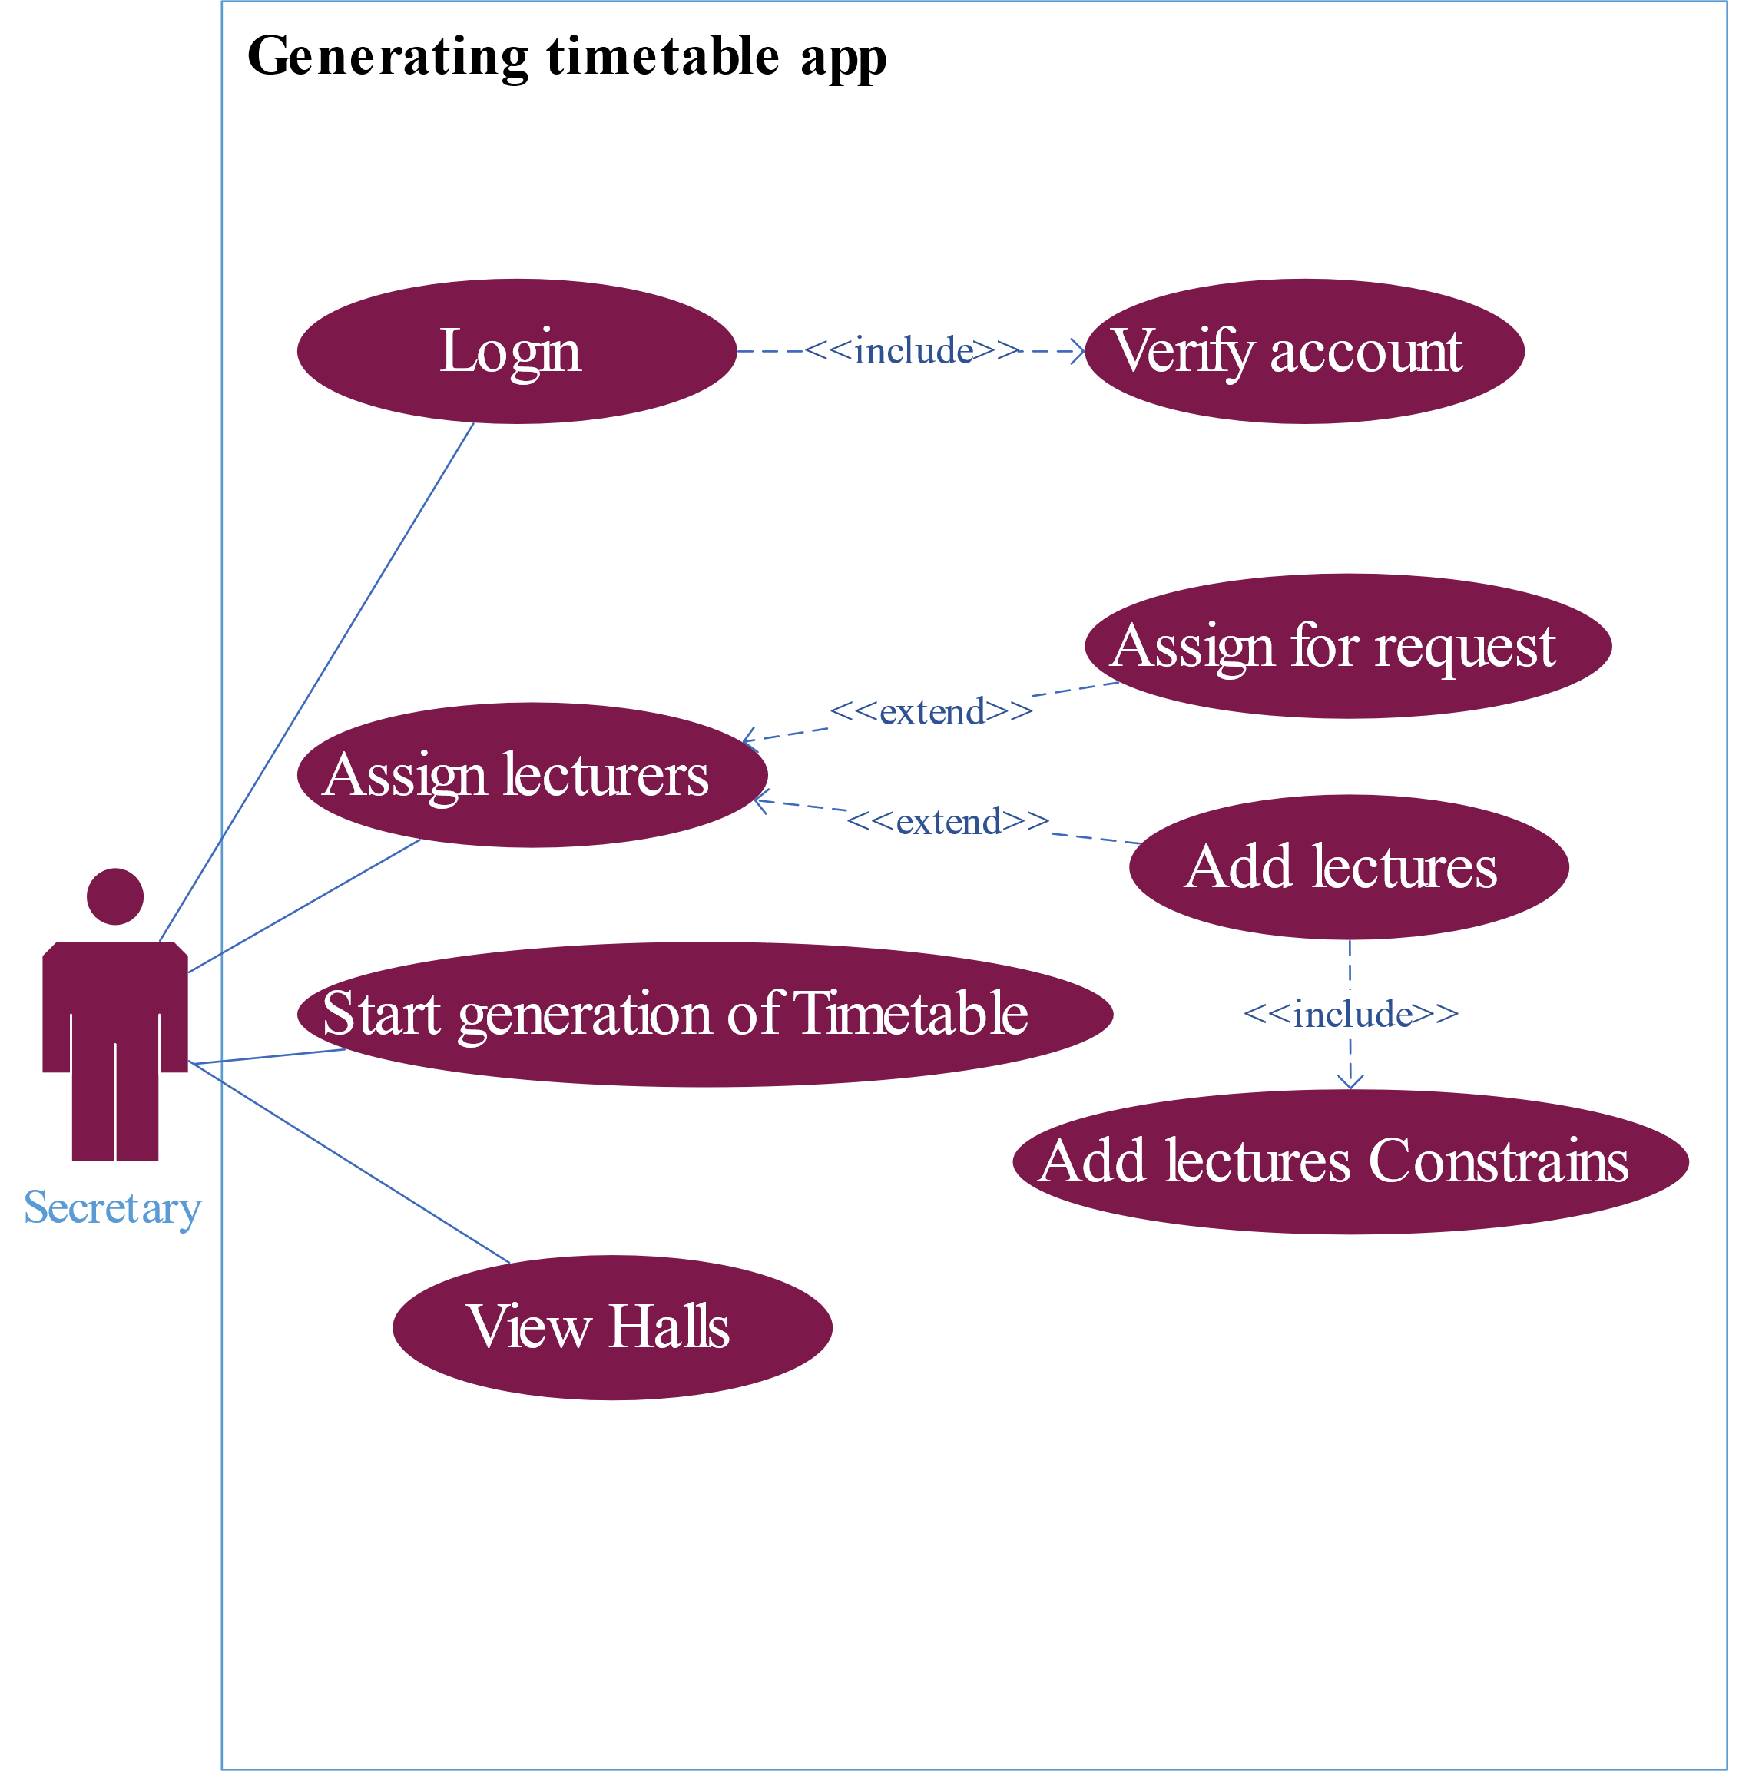

Figure ‑ Use case of college secretary

### The dataflow the system

After knowing how users deal with the system, the data flow begins between both users and the system. To facilitate the data visualization process, the context diagram (figure 3-6) generally shows the context of operations between all users and the system.

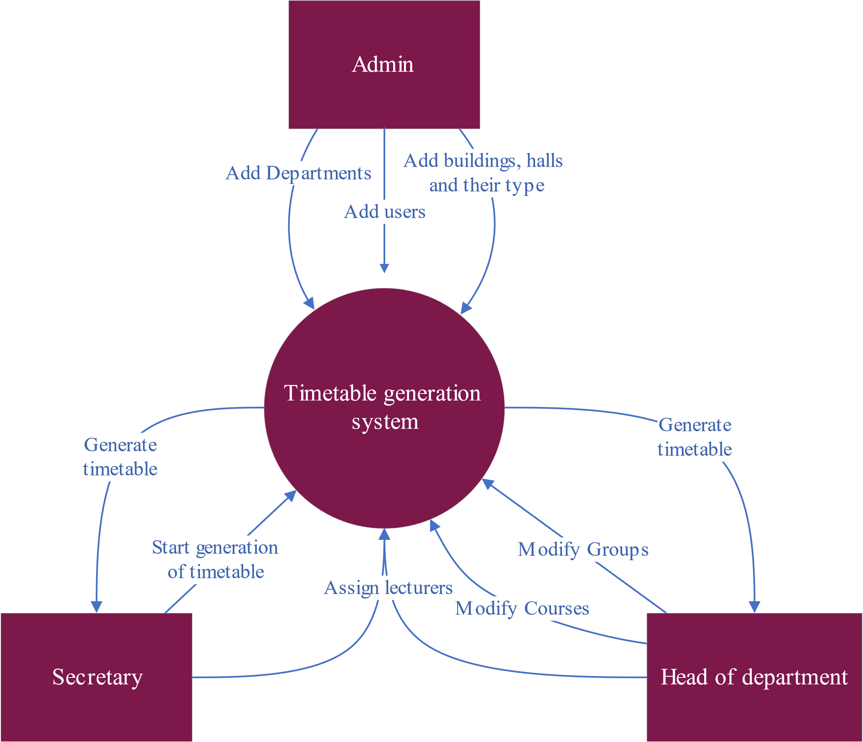

Figure ‑ Context diagram

As shown in figure6, each of the users first sends the data that the system needs to generate timetables, where the system stores it in its database and extracts what is needed to generate a timetable for each department of the college.

For a more comprehensive view of the data flow process, the data flow diagram (figure 3-7) shows where the data comes from, where it is stored, and where it is heading.

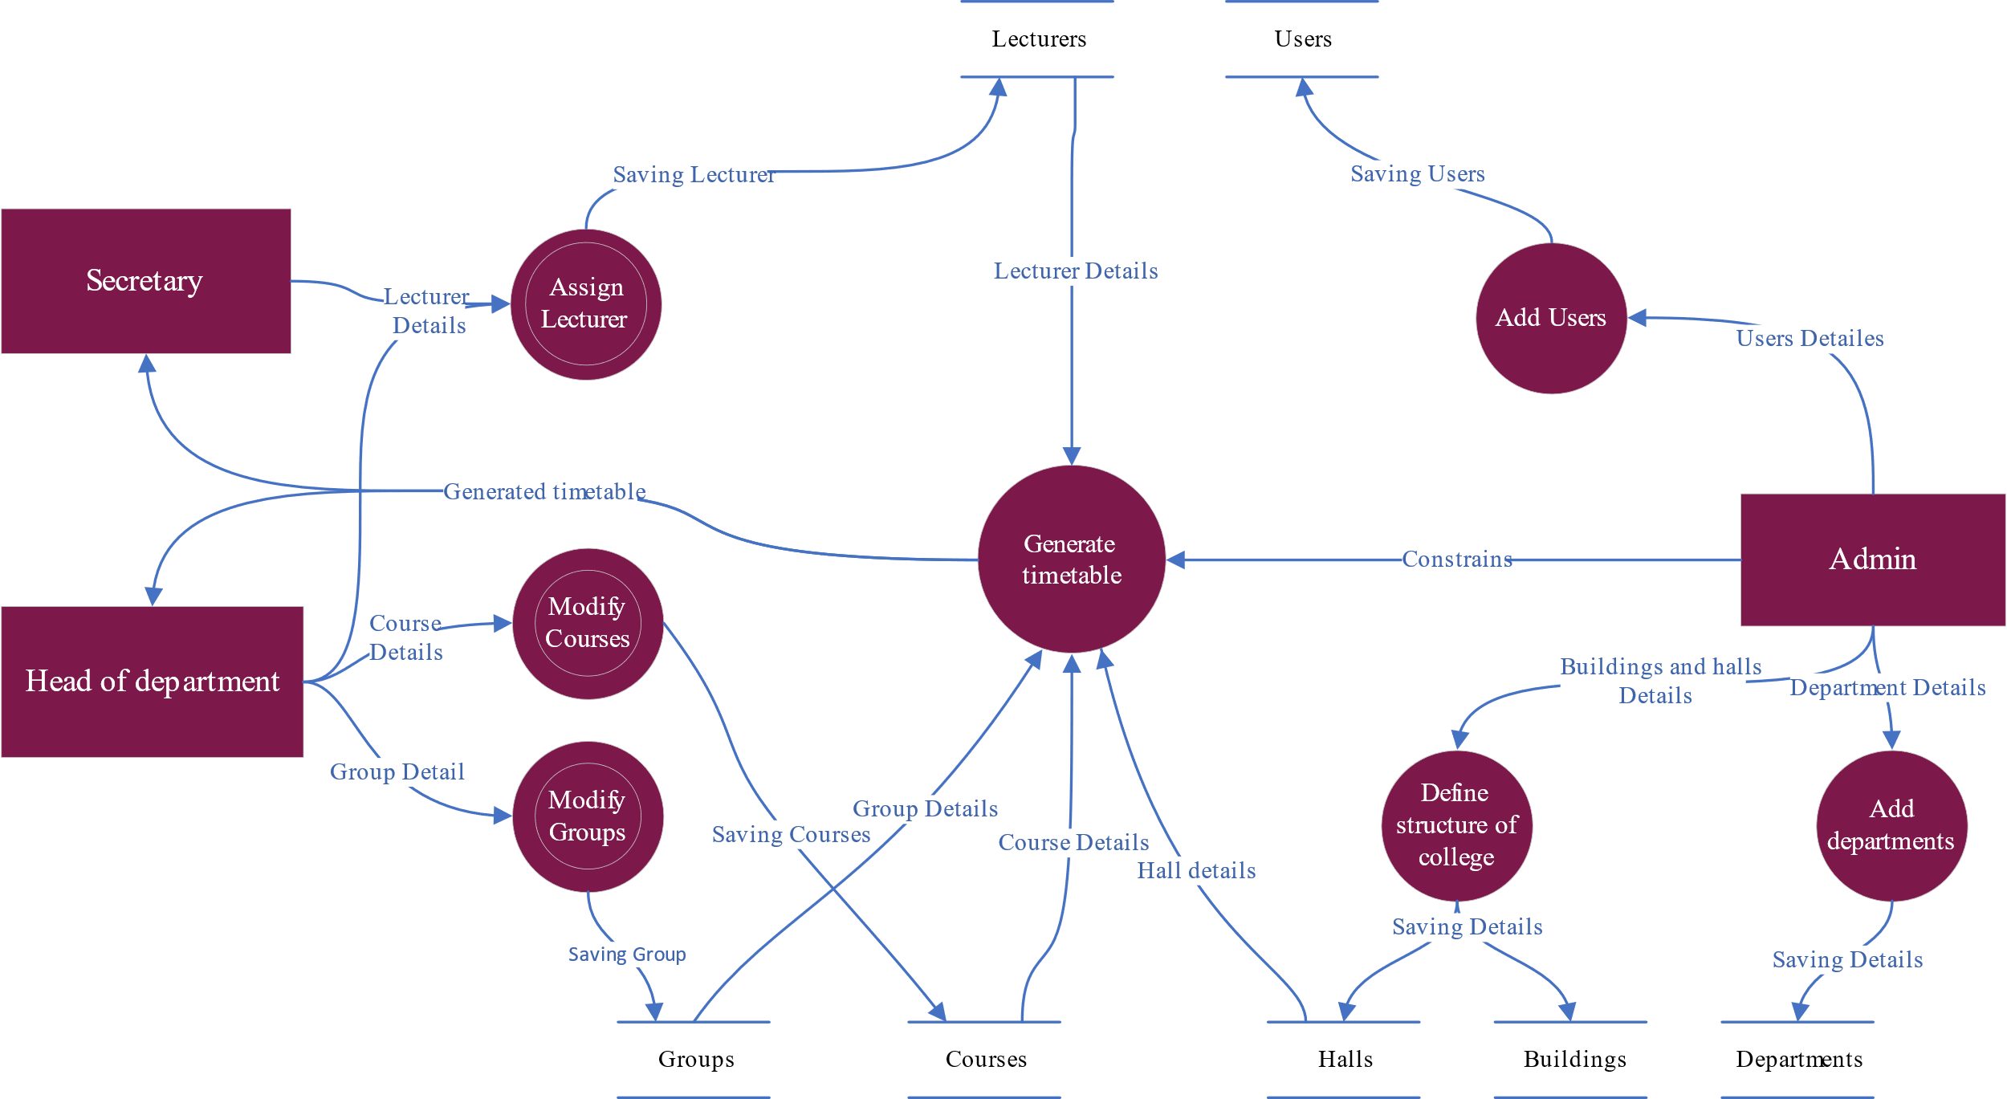

Figure ‑ Dataflow diagram

You can see in figure7 some of the processes that are symbolized by a circle with a white circle inside of it this figure indicates multiple processes, see the data flow process in the assigning of lecturers see (figure 3-8) You will find some other processes that make up this process.

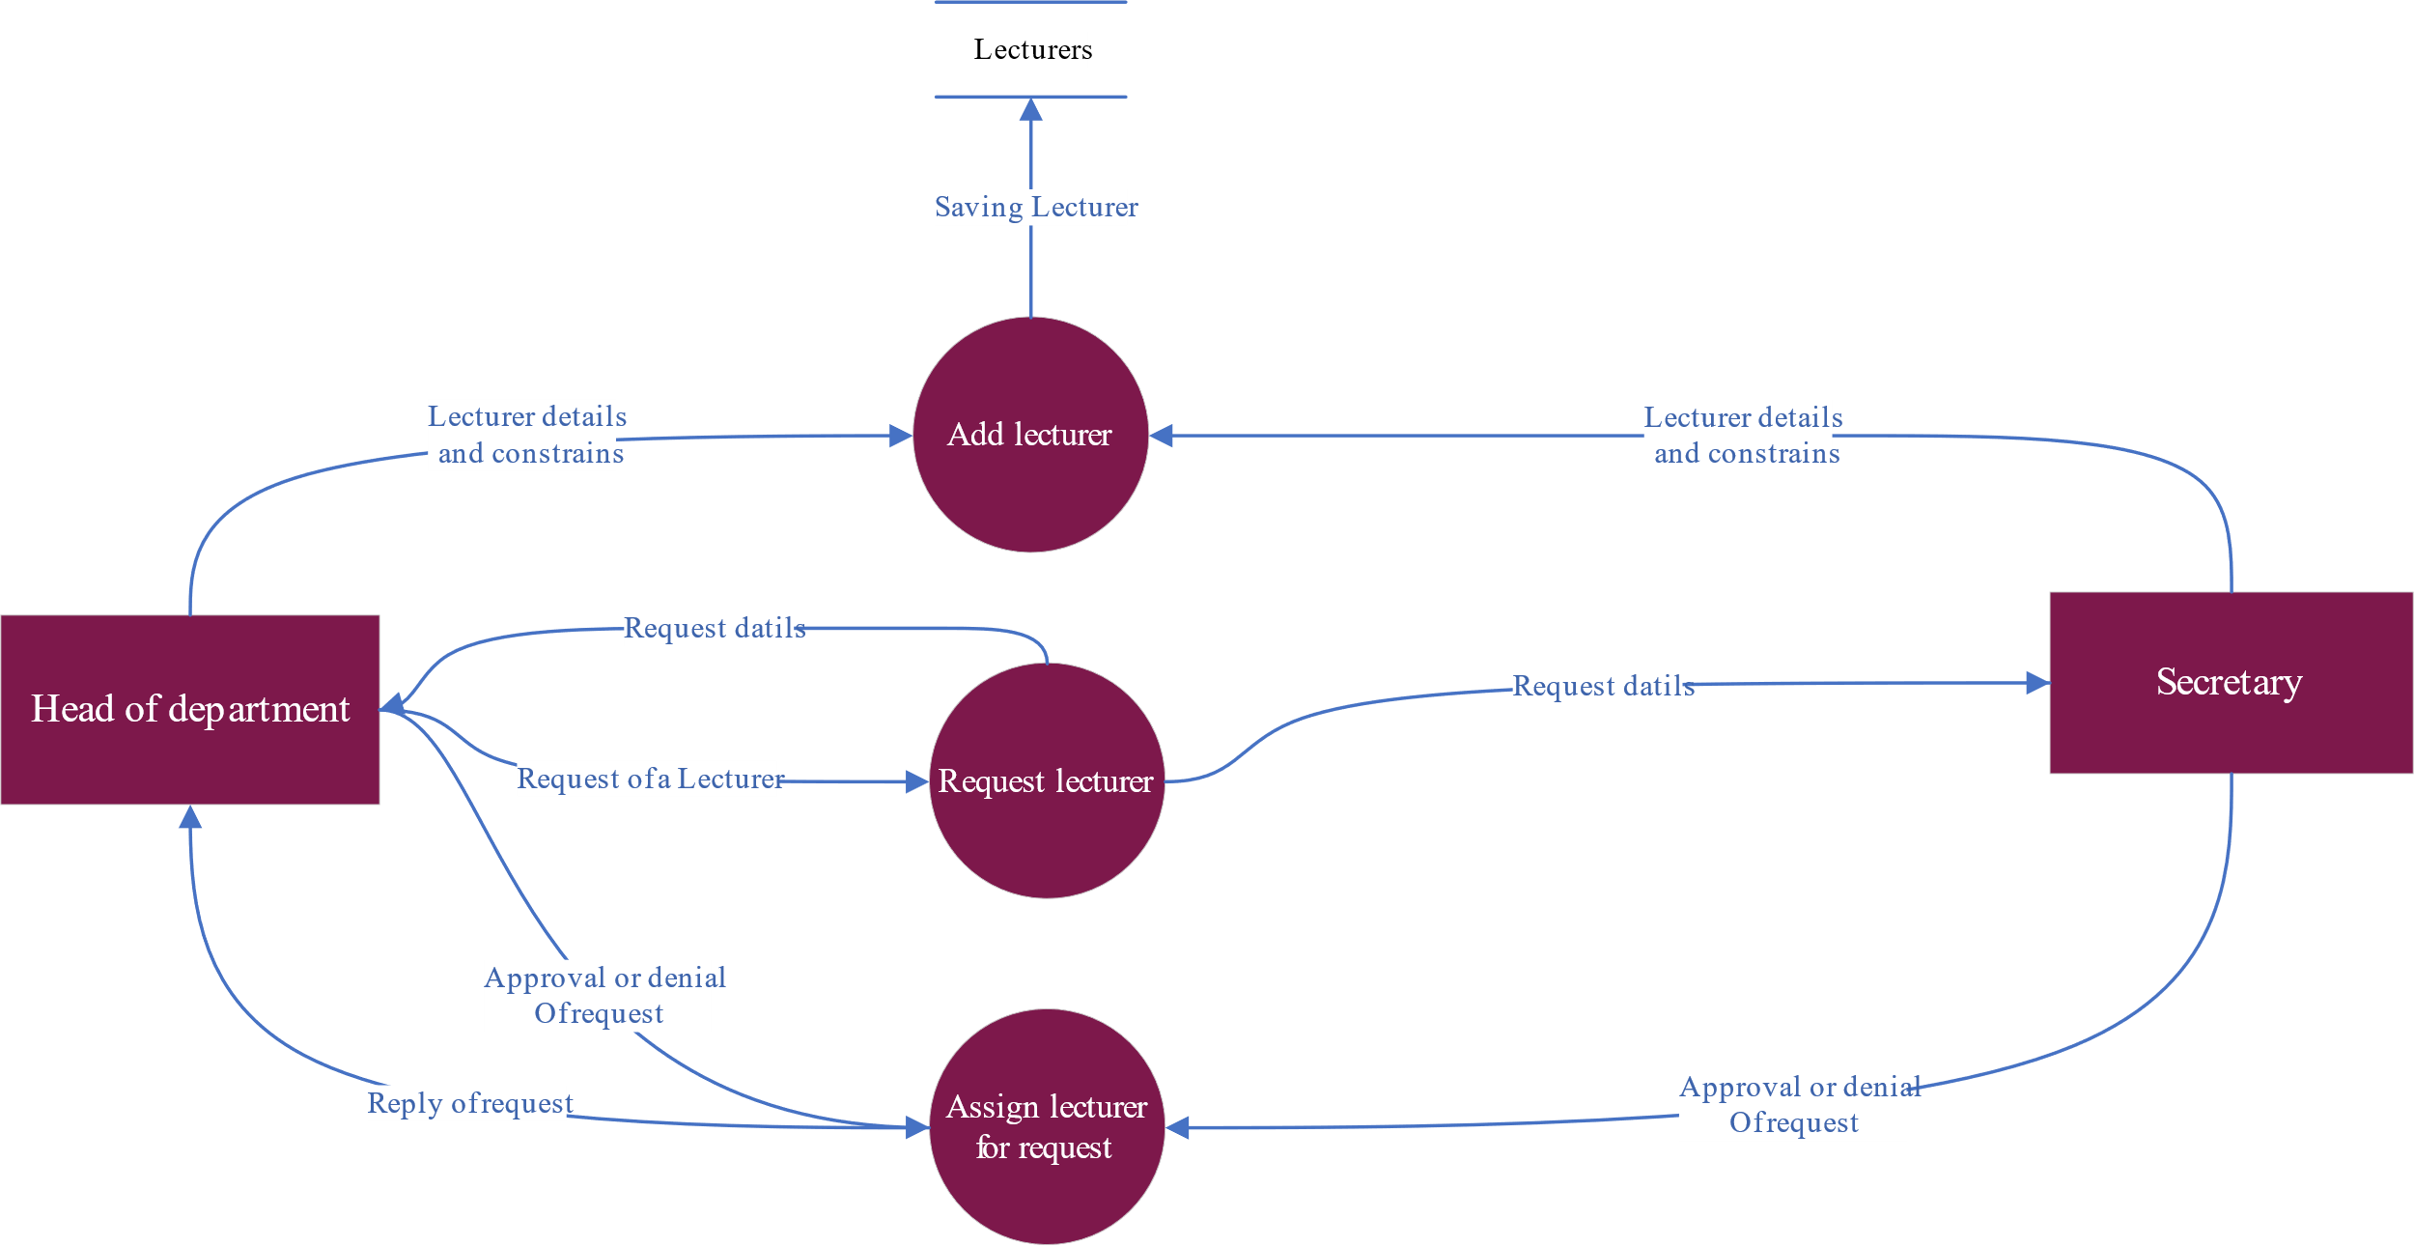

Figure ‑ dataflow diagram of multiple processes (assign lecturers)

### Database of the system

The database of the system (see Figure 3-9). The database consists of tables filled in by users, which are the tables that keep most of the data, and some tables are filled in automatically by the system to prepare the process of generating the timetable. In the end, the table (ETT) is the last table that the Tabu search deals with to generate the timetable.

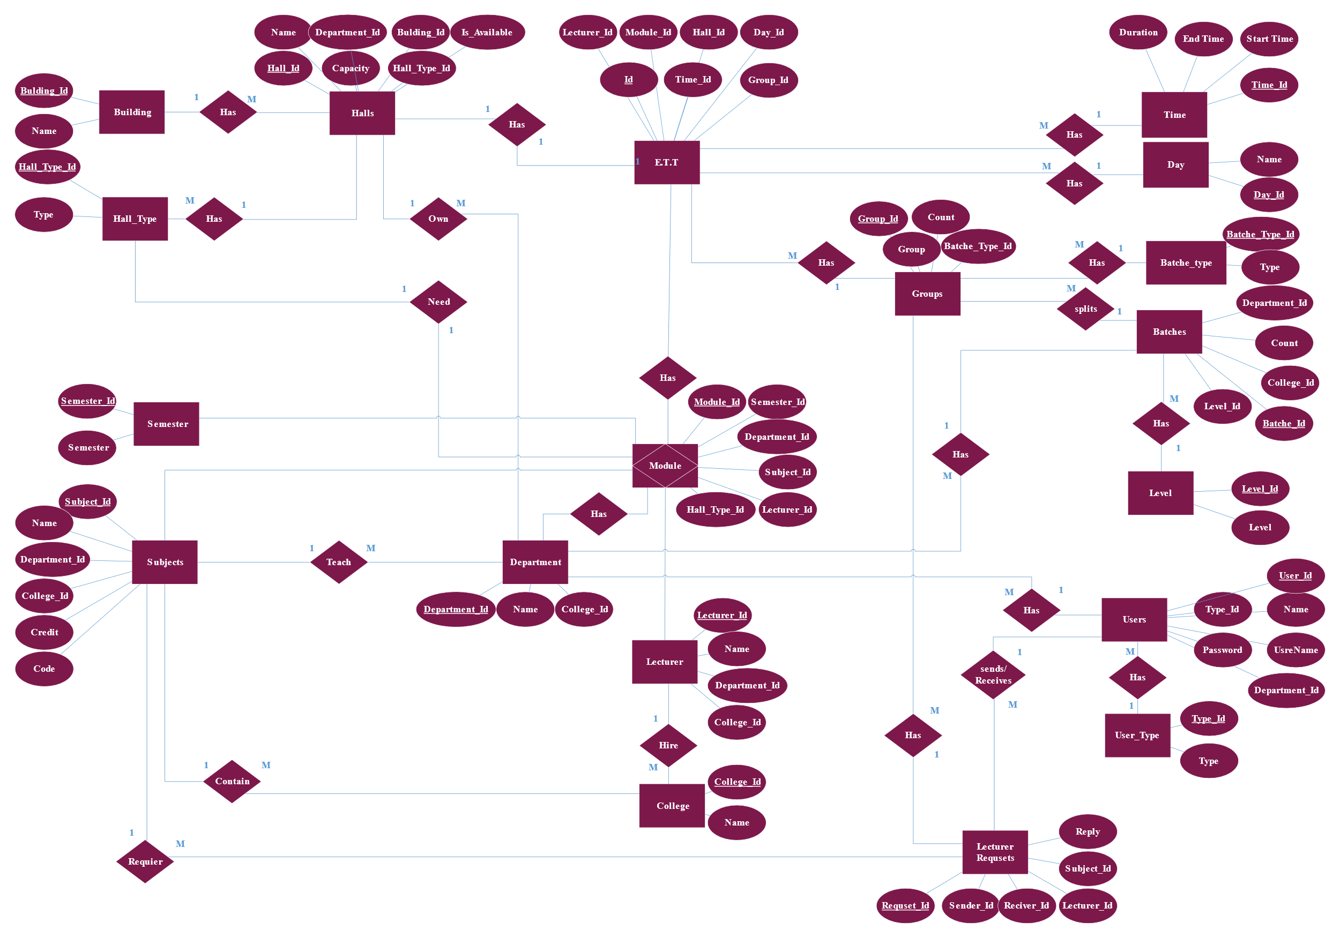

## Implementation and result

We were able to create a user-friendly interface that allows the users to easily access and interact to achieve the services they need.

### Main Page

The main page interface of our website is designed to be user-friendly and easy to navigate. The top bar includes quick links to navigate and a log in option

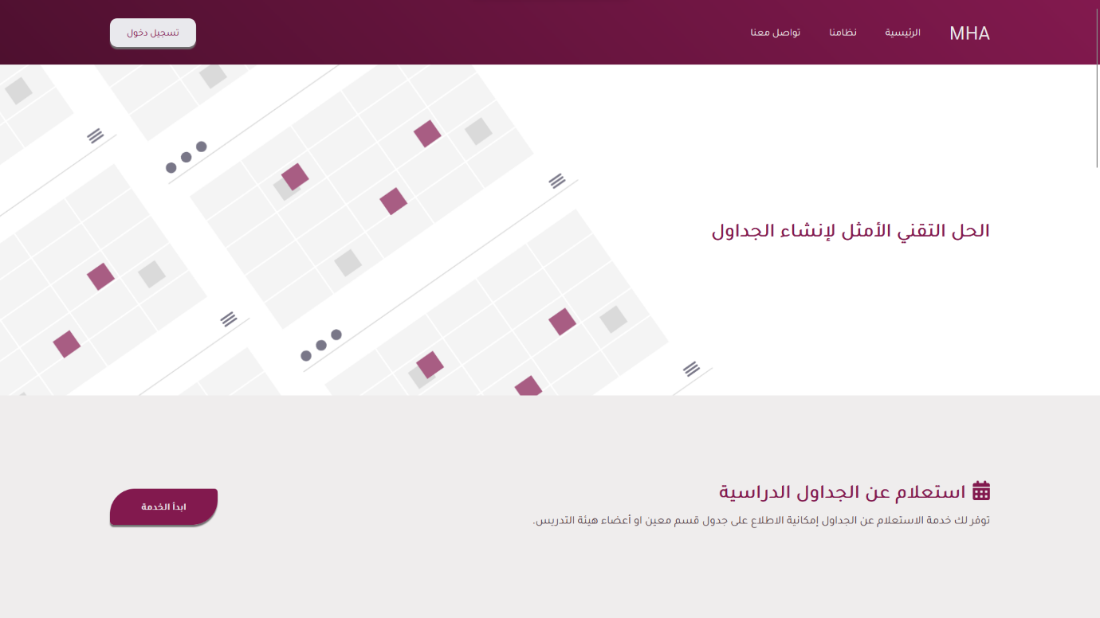

### Login Interface

The login interface of our website is simple and easy to use. The user enters their username and password and then clicks on the "تسجيل الدخول" button, our system will detect the user type and will navigate the user to the appropriate page

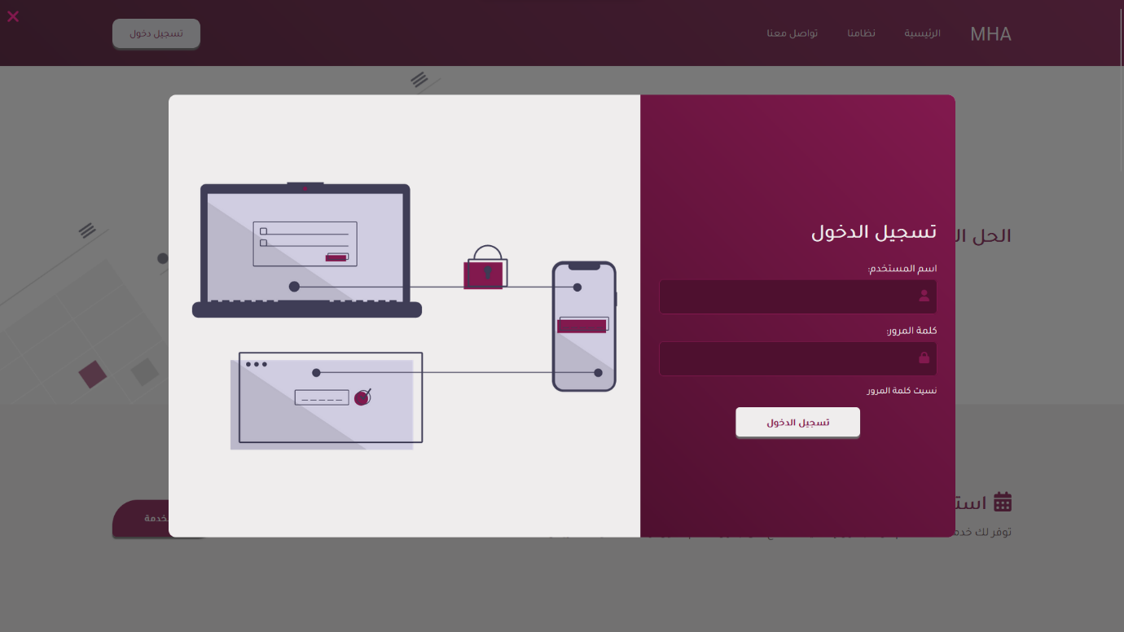

### Admin Homepage

The admin homepage contains a brief and quick view of the states of the system including the users, colleges, and number of departments

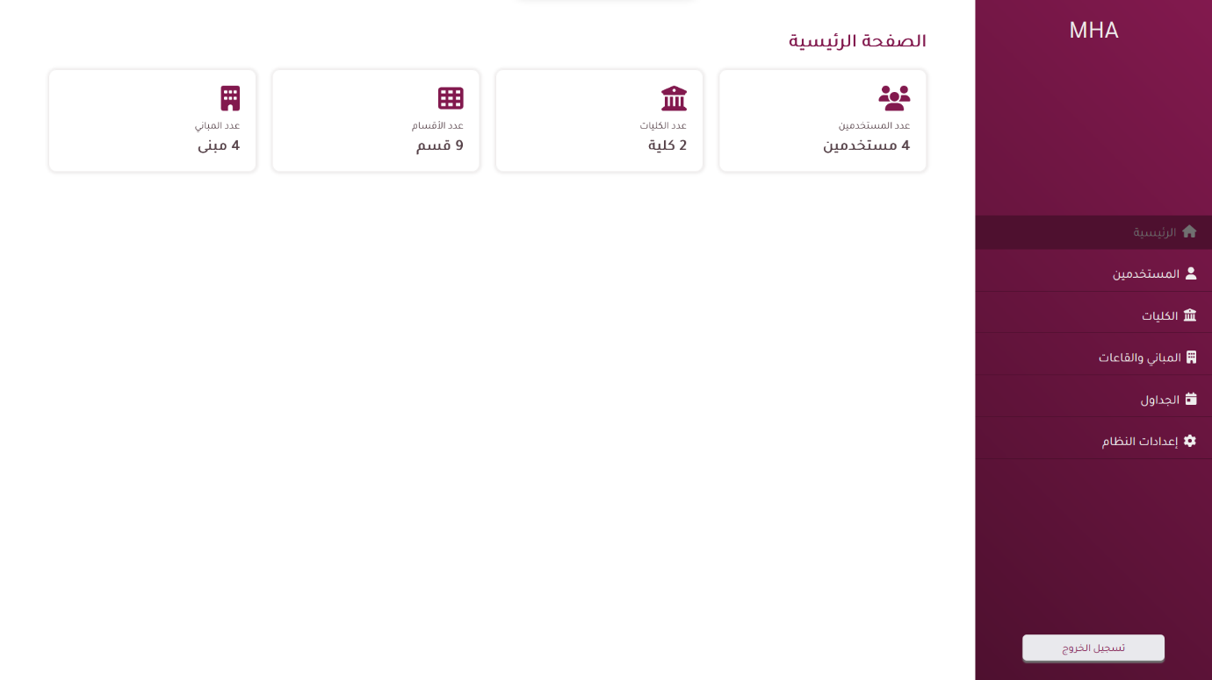

#### Admin Users Control

The user interface allows administrators to view and manage all users on the website. This includes the ability to create new users, edit existing users, and delete users.

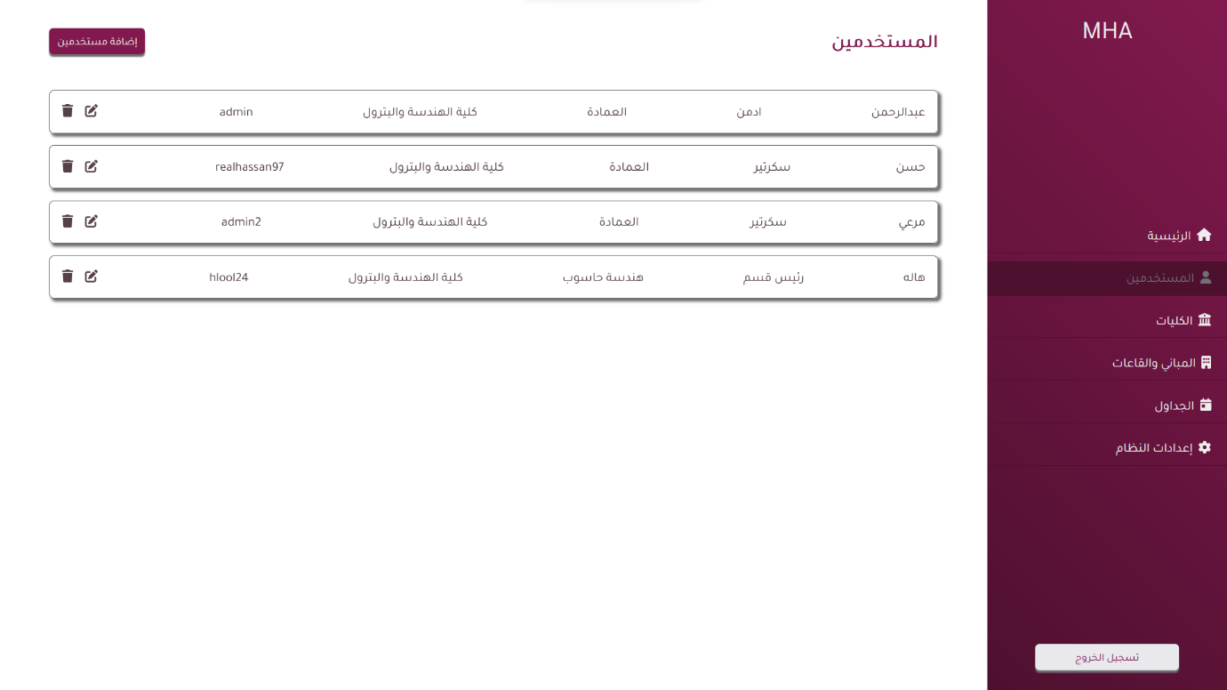

#### Admin Colleges

The college's interface allows administrators to view and manage all colleges. This includes the ability to create, edit, and delete.

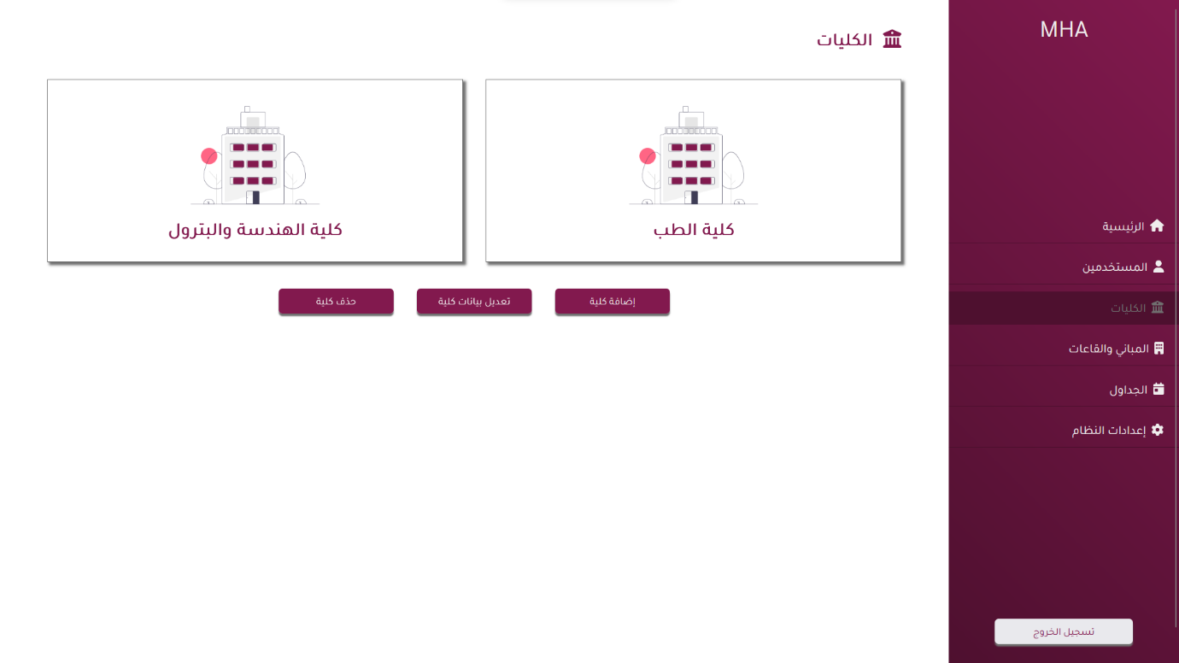

#### Admin Buildings

The building interface allows administrators to view and manage all buildings on the college campus. This includes the ability to create new buildings, edit existing buildings, and delete buildings, also the administrators can manage the types of classes those buildings will contain.

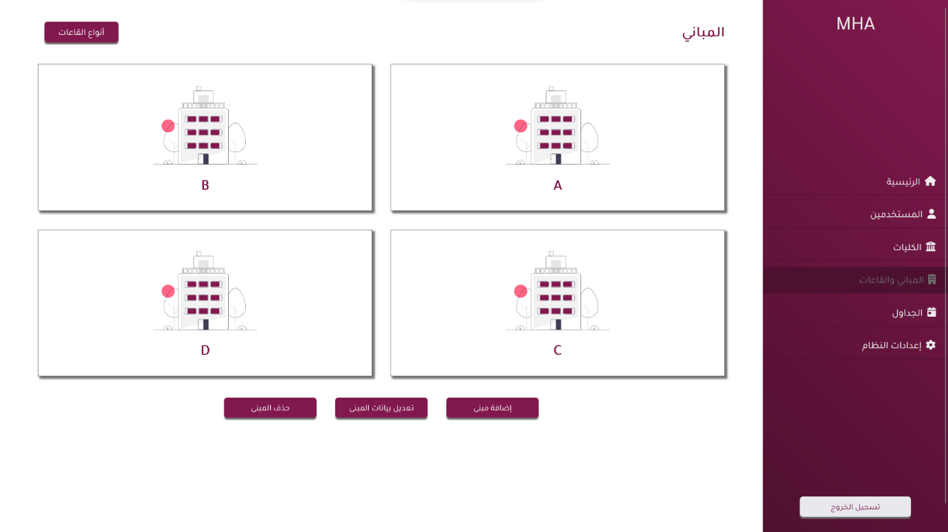

#### Admin Classes and Laps

The interface will allow the administrator to view and manage the classes and laps inside each building.

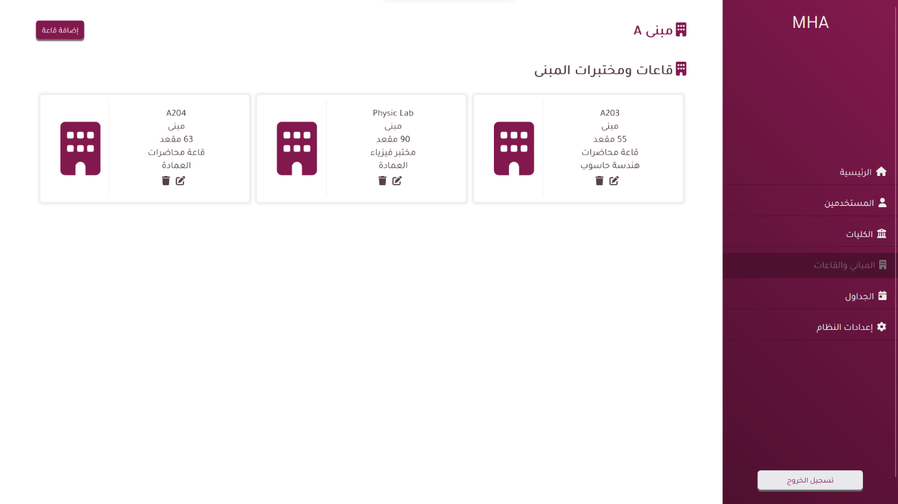

#### Admin Schedules

(template)

#### Admin Settings

The settings interface allows the administrator to manage some important system features including the year, semester, and schedule preferences.

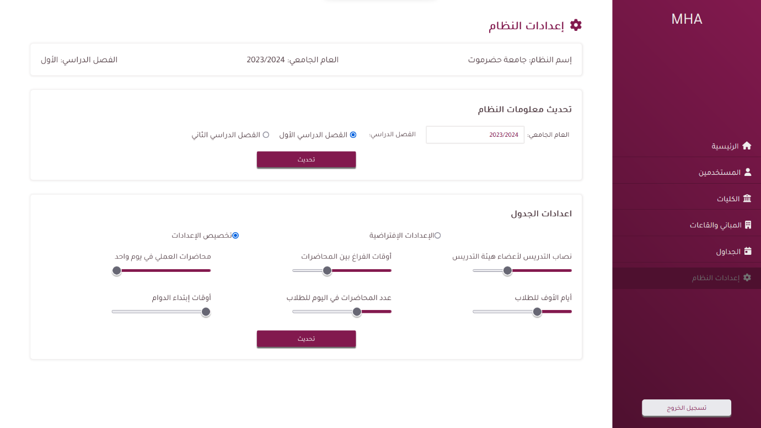

### Head of Department Homepage

The Head of the department homepage provides access to all interactions that are under his or her supervision.

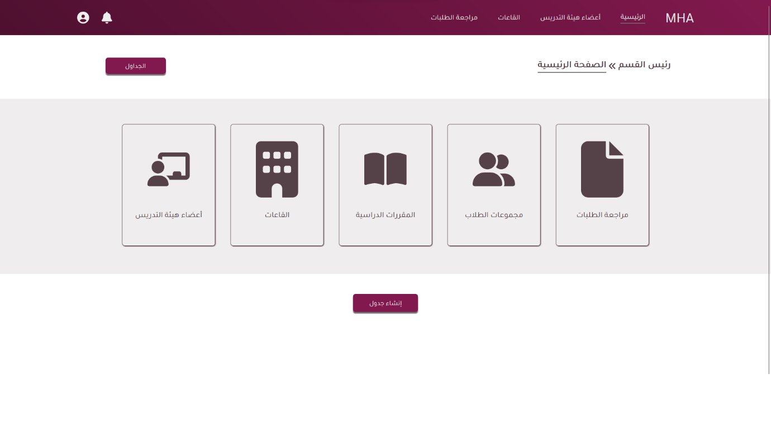

#### Head of Department Review Requests

The Request interface allows the head of the department to request to assign a class in his department with a teacher from another department.

(template)

#### Head of Department Groups

The student groups interface allows the head of the department to view and manage the groups of each batch.

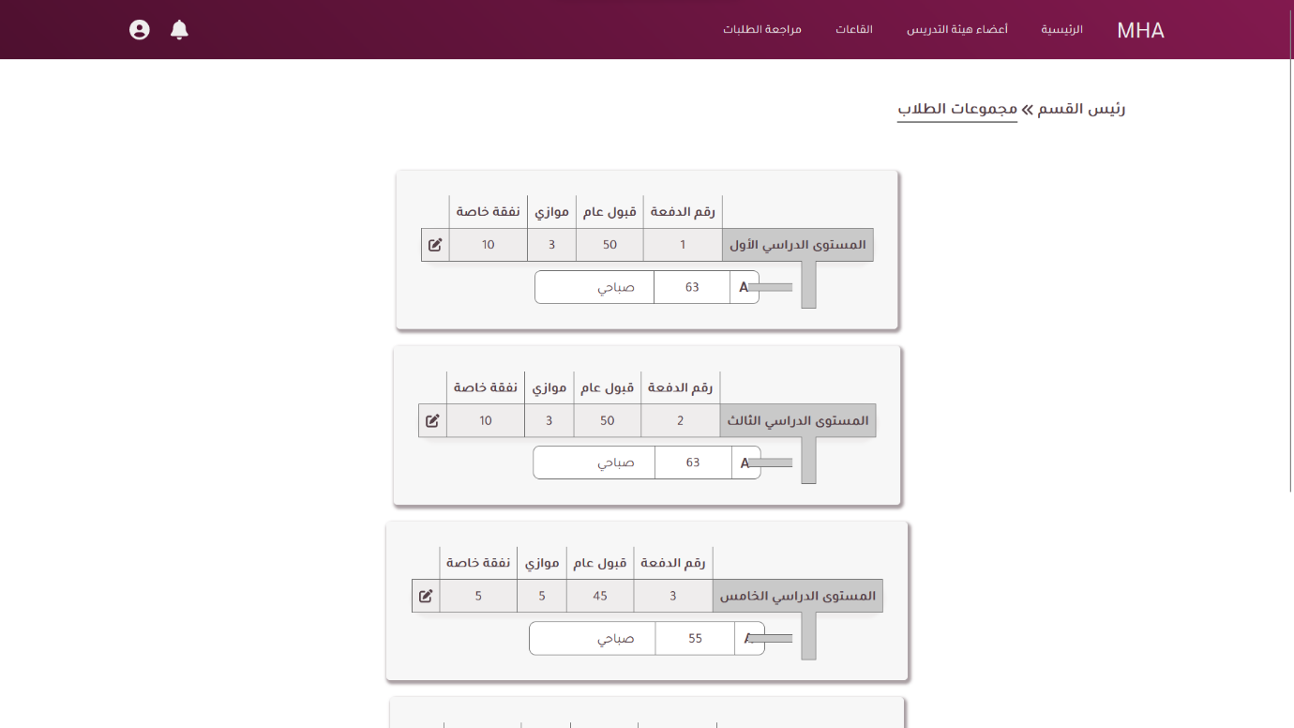

#### Head of Department Courses

The courses interface allows the head of the department to view and manage all courses for each batch that is under his or her supervision.

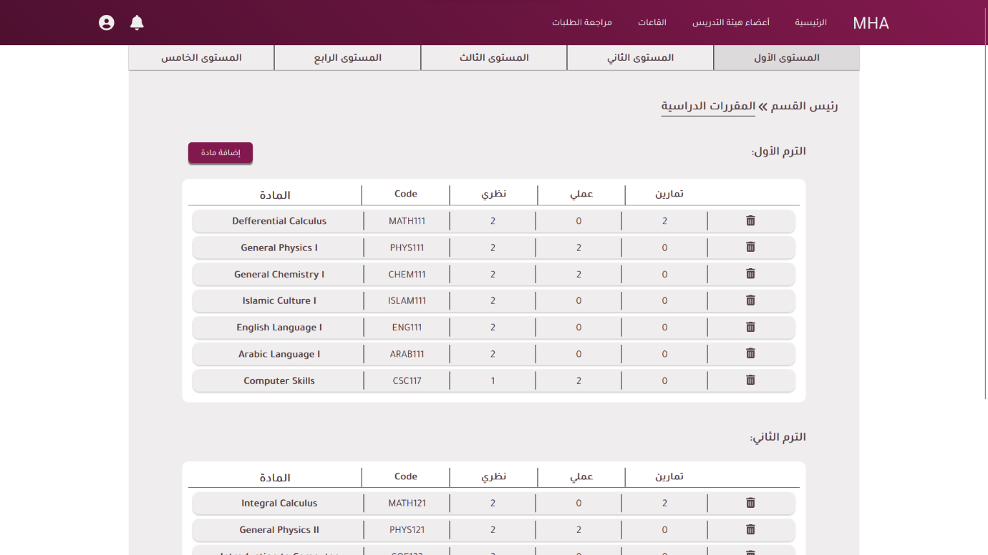

#### Head of Department Lecturers

The lecturer's interface allows the head of the department to manage all the lecturers in his department and their work days and if available or not.

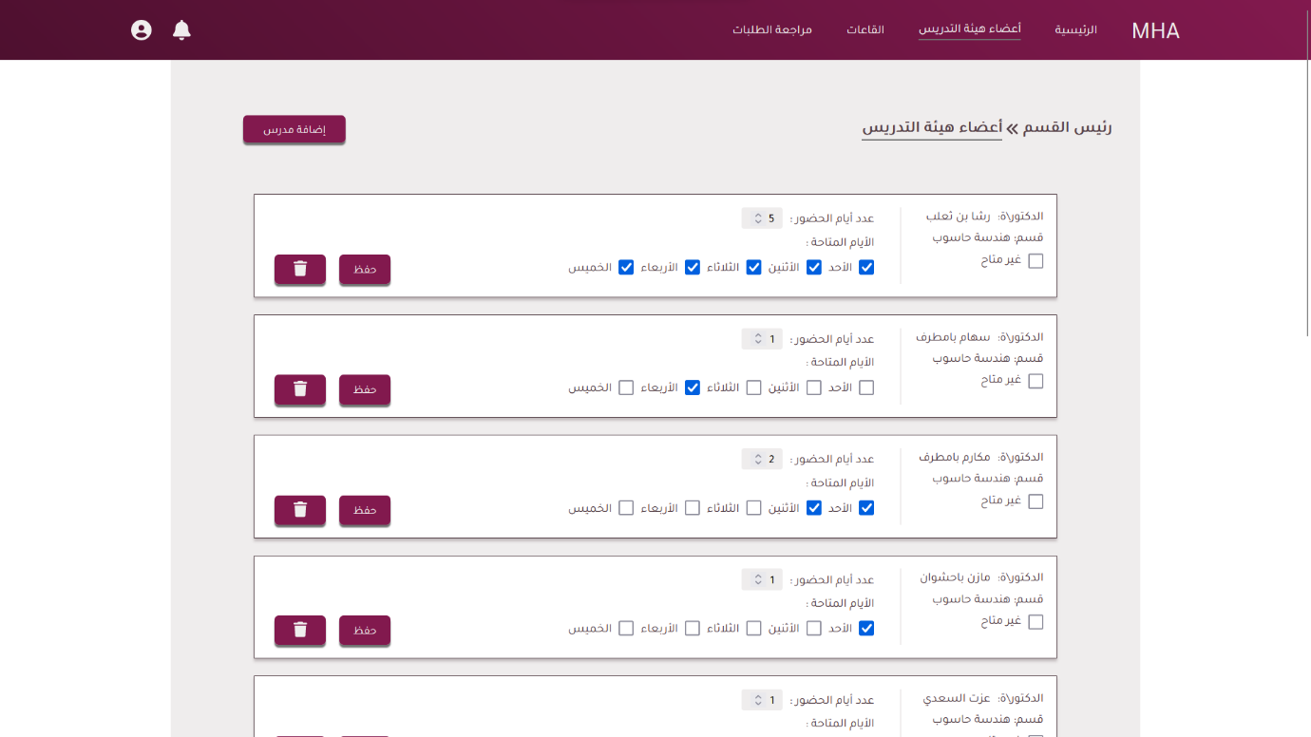

### Secretary Homepage

The secretary's homepage provides access to all interactions that are under his or her supervision.

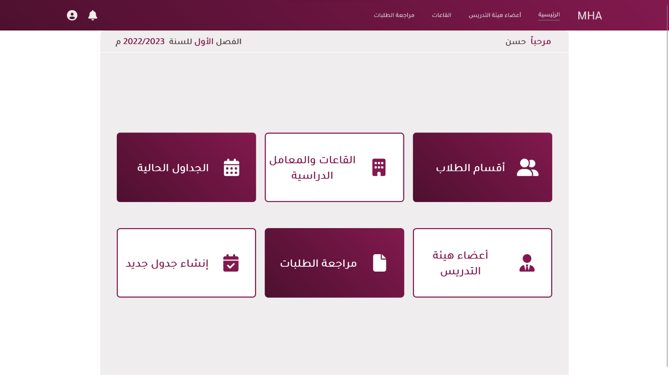

#### Secretary Lecturers

The lecturer interface allows the secretary to manage all the lecturers in the head of the departments and their work days and if available or not.

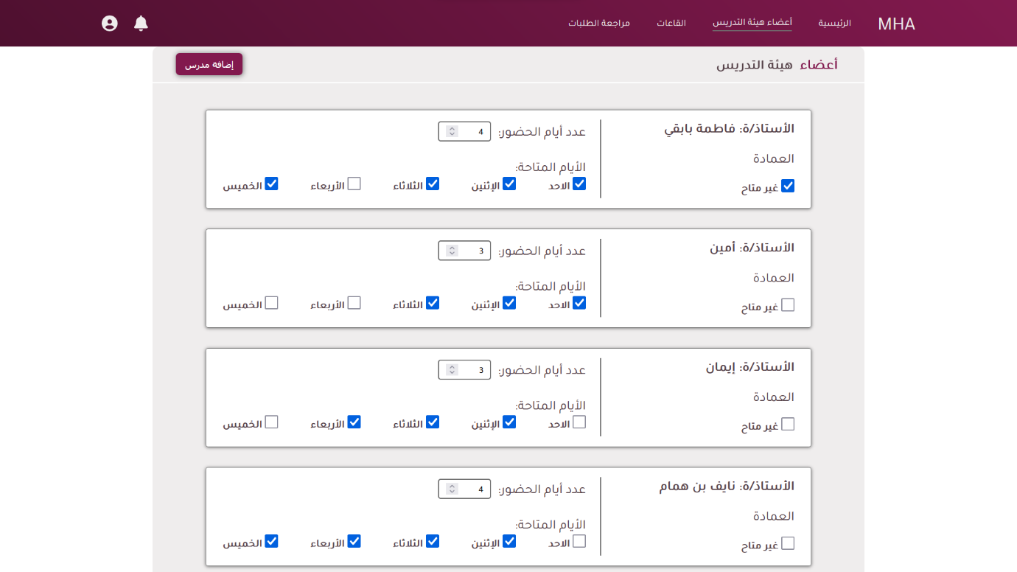

#### Secretary Current Schedules

(template)

#### Secretary Review Requests

The request interface allows the secretary to accept or decline the requests of the head department to assign a teacher from another department with a course.

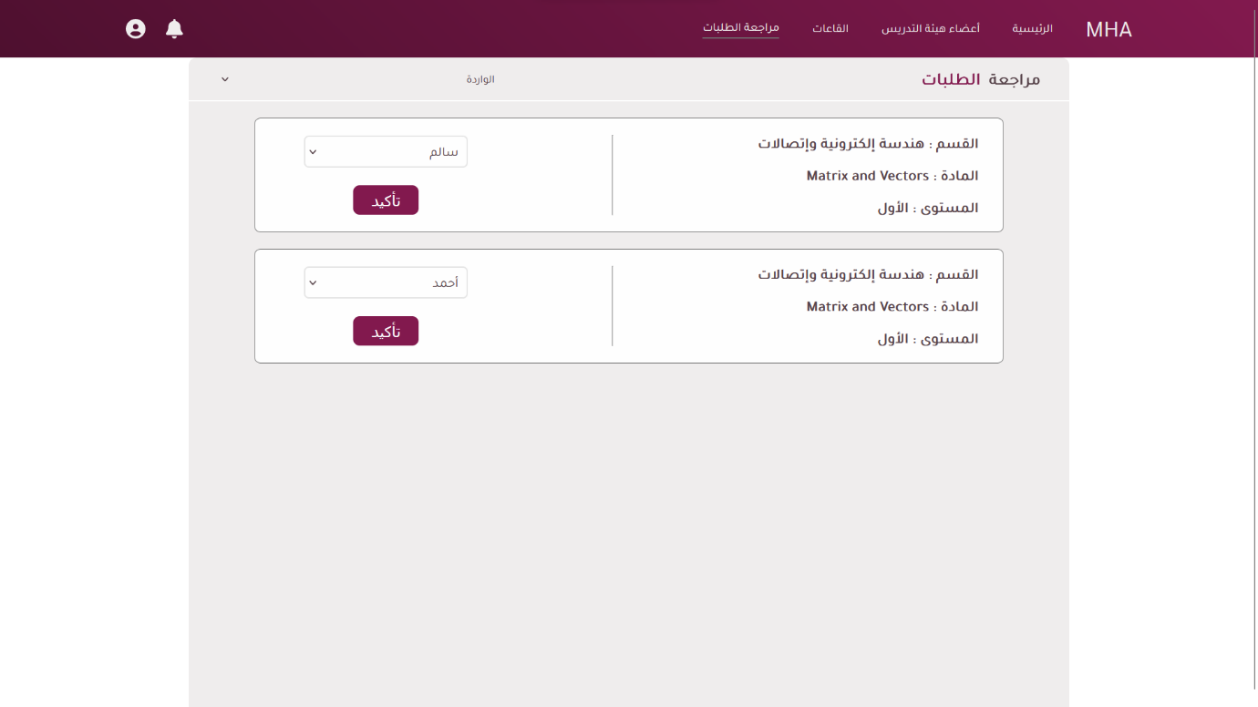

#### Secretary Schedules

The interface will allow providing to the secretary a brief view to the states of the current progress of the schedules for each department and last will allow the creation of the schedule

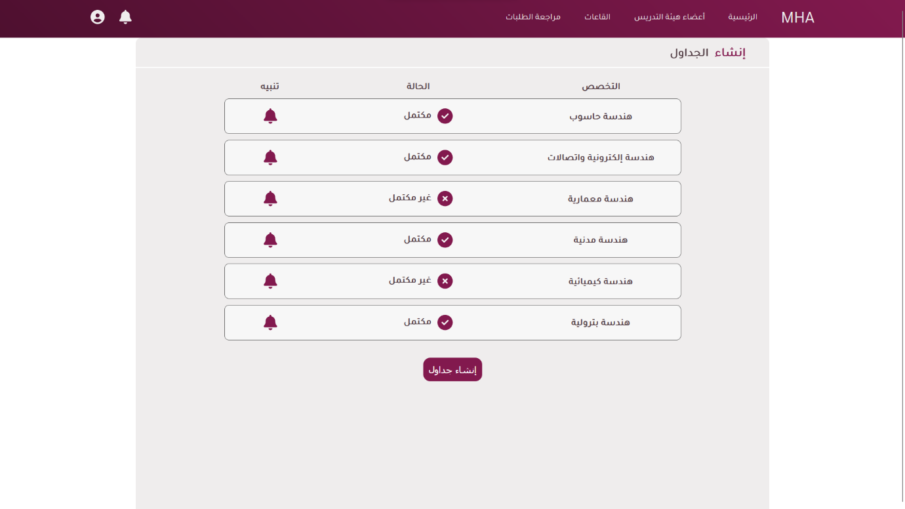

# References

[1] “Making a School Schedule.” https://www.my.gov.sa/wps/portal/snp/servicesDirectory/servicedetails/ (accessed Dec. 14, 2022).

[2] “GitHub - ghulamghousdev/Scheduly: Activity Scheduling Tool.” https://github.com/ghulamghousdev/Scheduly (accessed Dec. 14, 2022).

[3] F. Glover, “Tabu Search—Part I,” *ORSA Journal on Computing*, vol. 1, no. 3, pp. 190–206, Aug. 1989, doi: 10.1287/ijoc.1.3.190.

[4] F. Glover, “Tabu Search—Part II,” *ORSA Journal on Computing*, vol. 2, no. 1, pp. 4–32, Feb. 1990, doi: 10.1287/ijoc.2.1.4.

[5] “Introduction to HTML.” https://www.w3schools.com/html/html_intro.asp (accessed Dec. 14, 2022).

[6] “CSS Introduction.” https://www.w3schools.com/css/css_intro.asp (accessed Dec. 14, 2022).

[7] “JavaScript,” *Wikipedia*. Dec. 12, 2022. Accessed: Dec. 14, 2022. [Online]. Available: https://en.wikipedia.org/w/index.php?title=JavaScript&oldid=1127088475

[8] “Introduction to React.” https://www.w3schools.com/REACT/react_intro.asp (accessed Dec. 14, 2022).

[9] “Introduction to Node.js.” https://nodejs.dev/en/learn/ (accessed Dec. 14, 2022).

[10] “What is MySQL? Everything You Need to Know,” *Talend - A Leader in Data Integration & Data Integrity*. https://www.talend.com/resources/what-is-mysql/ (accessed Dec. 14, 2022).

[11] “Visual Studio Code,” *Wikipedia*. Feb. 25, 2021. Accessed: Dec. 14, 2022. [Online].

Available: https://en.wikipedia.org/w/index.php?title=Visual_Studio_Code&oldid=1008850700



**جامعة حضرموت**

**كلية الهندسة والبترول**

**قسم هندسة حاسوب**

**جدولة المحاضرات الجامعية**

**مشروع نهائي مقدم في استيفاء جزئي لمتطلبات درجة بكالوريوس الهندسة في هندسة الحاسوب**

**إعداد**

**حسن محمد الحامد**

**عبد الرحمن احمد بهيان**

**مرعي فوزي بن طالب**

**هاله مرعي بن هلابي**

**إشراف**

**د. مكارم بامطرف**

**المكلا**

**مارس-2023**